Thermal Conductivity Meter

By

Isayah Bannister

Contents
1. INTRODUCTION 7
a. Description 7
b. Motivation 7
c. Function Statement 7
d. Requirements 7
e. Engineering Merit 8
f. Scope of Effort 8
g. Success Criteria 8
h. Stakeholders 8
2. DESIGN & ANALYSIS 9
a. Approach: Proposed Solution 9
b. Design Description 9
c. Benchmark 9
d. Performance Predictions 9
e. Description of Analysis 9
f. Scope of Testing and Evaluation 10
g. Analysis 10
i. Analysis 1 – Controlling Factors to Match Fourier’s Heat Conduction 10
ii. Analysis 2 – Sufficiency of Arduino Uno R3 Supplied Power 11
iii. Analysis 3 – Wall-Arduino Power Transformer 11
iv. Analysis 4 – Liquid Probe Tube Deflection 11
v. Analysis 5 – Wheatstone Bridge Balance 11
vi. Analysis 6 – Liquid Container Lid Clamping Force 12
vii. Analysis 7 – Electrical Computing System Weight 12
viii. Analysis 8 – Characteristic Length of Solid Sample 12
ix. Analysis 9 – Thin-film Thermistor Bending 12
x. Analysis 10 – Total Power Drawn 13
h. Device: Parts, Shapes, and Conformation 13
i. Device Assembly 13
j. Technical Risk Analysis 13
k. Failure Mode Analysis 14
l. Operation Limits and Safety 14
3. METHODS & CONSTRUCTION 15
a. Methods 15
i. Process Decisions 15
b. Construction 16
i. Description 16
ii. Drawing Tree, Drawing ID’s 17
iii. Parts 18
iv. Manufacturing Issues 19
v. Discussion of Assembly 20
4. TESTING 21
a. Introduction 21
b. Method/Approach 21
c. Test Process 22
d. Deliverables 22
5. BUDGET 23
a. Parts 23
b. Outsourcing 23
c. Labor 23
d. Estimated Total Project Cost 23
e. Funding Source 23
f. Winter Updates 24
g. Spring Updates 24
6. SCHEDULE 25
a. Design 25
b. Construction 25
c. Testing 25
7. PROJECT MANAGEMENT 27
a. Human Resources 27
b. Physical Resources 27
c. Soft Resources 28
d. Financial Resources 28
8. DISCUSSION 29
a. Design 29
b. Construction 30
c. Testing 31
9. CONCLUSION 32
a. Design 32
b. Construction 32
c. Testing 32
10. ACKNOWLEDGEMENTS 33
References 34
APPENDIX A - Analysis 35
Appendix A01 – Controlling Factors to Match Fourier’s Heat Conduction 35
Appendix A02 – Sufficiency of Arduino Uno Rev3 Supplied Power 38
Appendix A03 – Wall-Arduino Power Transformer 41
Appendix A04 – Liquid Probe Tube Deflection 42
Appendix A05 – Wheatstone Bridge Balance 43
Appendix A06 – Liquid Container Lid Clamping Force 46
Appendix A07 – Electrical Computing System Weight 48
Appendix A08 – Characteristic Length of Solid Sample 49
Appendix A09 – Thin-film Thermistor Bending 52
Appendix A10 – Total Power Drawn 54
APPENDIX B - Drawings 57
Appendix B01 – Drawing Tree 57
Appendix B02 – Drawing Index 60
Appendix B03 – IBB-10-001 – Liquid Probe Mounting Assembly 61
Appendix B04 – IBB-10-002 – Probe Standoff Mount Assembly 62
Appendix B05 – IBB-10-003 – Solid Sample Measurement Stand Assembly 63
Appendix B06 – IBB-10-004 – Probe Standoff Mount Assembly 64
Appendix B07 – IBB-10-005 – Electronic Computing Assembly 65
Appendix B08 – IBB-20-001 – Thermistor Tube Clamp 66
Appendix B09 – IBB-20-002 – Liquid Probe Sample Container Mount 67
Appendix B10 – IBB-20-003 – Thermistor Housing Tube 68
Appendix B11 – IBB-20-004 – Container Lid Pinch Clamp 69
Appendix B12 – IBB-20-005 – Control System Container Lid 70
Appendix B13 – IBB-20-006 – Control System Container 71
Appendix B14 – IBB-20-007 – Thermistor Clamp (Male Side) 72
Appendix B15 – IBB-20-008 – Thermistor Clamp (Female Side) 73
Appendix B16 – IBB-20-009 – Solid Sample 74
Appendix B17 – IBB-20-010 – Solid Sample Holder 75
Appendix B18 – IBB-20-010 – Foam Insert 76
Appendix B19 – IBB-20-012 – Jar Lid 77
Appendix B20 – IBB-20-013 – Electronics Schematic 78
Appendix B21 – IBB-55-001 – T-Slotted Framing Rail 79
Appendix B22 – IBB-55-002 – Arduino Uno R3 80
Appendix B23 – IBB-55-003 – Adafruit Perma-Proto Half-sized Breadboard PCB 81
Appendix B24 – IBB-55-004 – Ultra Thin 10K Thermistor – B3950 NTC 82
Appendix B25 – IBB-55-005 – Adafruit LCD 16x2 83
Appendix B26 – IBB-55-006 – Trim Potentiometer – 10K 84
Appendix B27 – IBB-55-007 – Toggle Switch 85
Appendix B28 – IBB-55-008 – Red LED 86
Appendix B29 – IBB-55-009 – Ball Wide Mouth Leakproof Storage Lid 87
APPENDIX C – Parts List and Costs 88
APPENDIX D – Budget 90
APPENDIX E – Schedule 91
Appendix F – Expertise and Resources 94
APPENDIX G – Testing Report 98
Appendix G1 (Room Temperature Water) 98
Introduction 98
Method/Approach 98
Test Procedure 98
Deliverables 98
Appendix G1.1 – Procedure Checklist 98
Appendix G1.2 – Data Forms 98
Appendix G1.3 – Raw Data 98
Appendix G1.4 – Evaluation Sheet 98
Appendix G1.5 – Schedule (Testing) 98
Appendix G2 (Near-Freezing Water) 99
Introduction 99
Method/Approach 99
Test Procedure 99
Deliverables 99
Appendix G2.1 – Procedure Checklist 99
Appendix G2.2 – Data Forms 99
Appendix G2.3 – Raw Data 99
Appendix G2.4 – Evaluation Sheet 99
Appendix G2.5 – Schedule (Testing) 99
Appendix G3 (Appendix Solid) 100
Introduction 100
Method/Approach 100
Test Procedure 100
Deliverables 100
Appendix G3.1 – Procedure Checklist 100
Appendix G3.2 – Data Forms 100
Appendix G3.3 – Raw Data 100
Appendix G3.4 – Evaluation Sheet 100
Appendix G3.5 – Schedule (Testing) 100
Appendix H – Resume 101

1. INTRODUCTION

a. Description
Thermal conductivity is an important factor used in analyzing a material’s heat transferring properties, yet when working with irregular or uncommon materials, their thermal conductivity might not be known and not recorded in any accessible databases. The goal of this project is to create a compact, inexpensive unit able to conduct rapid measurements for small-scale projects.

b. Motivation
A thermal conductivity measurer is desired for the MET316LAB course. It would be used sparsely but would be an effective tool to illustrate thermal conductivity in a lab setting. Commercially available thermal conductivity measurement systems are typically large, complex, and expensive; all of which cannot be accommodated for within the lab scope and budget. Engineering a system which is compact, inexpensive, and easily upkept or upgraded would provide the lab with a learning resource and future students an opportunity to explore instrumentation.

c. Function Statement
To create a system which measures the thermal conductivity of a given liquid or solid sample.

d. Requirements
- The device must be constructed of readily available materials that can be purchased from hardware and/or online supply stores. The total cost spent assembling the system cannot exceed $1,000.
- Must be powered using standard batteries or AC 120V 60Hz outlets.
- The total weight of the entire system must not exceed 20 pounds.
- The system must fit within an 18”x13”x10” box (accessory components do not count towards this).
- The component that interfaces with the material being tested, i.e. the probe, should be easily replaceable with an identical part. One such replacement component must also be manufactured. The cost of the component cannot exceed $150.
- The device must be able to measure the thermal conductivity and bulk liquids and solids within 5% of reference values.
- Test materials must have a minimum characteristic length of 1 cm
- The device must measure the thermal conductivity within 15 minutes of initiating the measurement.
- Measurement preparation time should not exceed 45 minutes.
- The device must retain measurement data or plot data to a .xslx file. Key data points to retain are the initial and final material temperature, and heat flow. Other pertinent data, i.e. material surface area, can be manually inserted by the user.
- The device must have a live display showing measurement progress in real time. The displays must have a refresh rate greater than 60 Hz. At least two displays are necessary which show change in temperature and heat flow respectively. Furthermore, an indicator light must be present to show when a measurement is in progress or complete

e. Engineering Merit
The project revolves around accurately analyzing thermal conductivity, which is a property of Heat Transfer and to a lesser degree, Thermodynamics. Instrumentation and Digital Circuits will be used to connect the probes with the processors capable of analyzing the measured data. In order to unite the circuitry and probes, Mechanics of Materials will be used to ensure everything is wrapped in a compact, stable housing.

f. Scope of Effort
The scope of this project involves construction of a central data-processing unit and probes adapted to measuring liquids and solids. The system will require coding to process and graph measured data. Further efforts will include part-sourcing and creating electronic assemblies.

g. Success Criteria
The system successfully measures the thermal conductivity of four materials within 5% of the reference thermal conductivity values of those materials. These materials are as follows:
- Water OR 1% gelatin + 99% water (weight percentages) at room temperature
- Water OR 1% gelatin + 99% water (weight percentages) at a temperature below room temperature and above freezing
- A potato OR apple OR sausage at room temperature
- A solid listed in Appendix A-24 or A-25 of the Cengel Thermal-Fluids book, at a known temperature

h. Stakeholders
The stakeholders of this project include Professor Pringle and Professor Choi. Professor Pringle and Professor Choi provided guidance throughout this project. Professor Choi also provided the white paper which laid out this engineering problem and assistance specialized in thermodynamics and heat transfer.

2. DESIGN & ANALYSIS

a. Approach: Proposed Solution
A device which can measure thermal conductivity within 5% of reference values
The Thermal Conductivity Meter must have two types of probes: one for measuring solids and one for liquids. Both need to have the necessary instrumentation to measure the heat energy it imparts to the material and the temperature change of the material. The microcontroller must then take these measurements and the time over which they occurred and calculate the thermal conductivity of the material.

b. Design Description
The Thermal Conductivity Meter will be a 10” x 10” x 5” box which houses an Arduino capable of reading, analyzing, and uploading data from a probe. The Arduino will act as the microcontroller, computational system, and power supply for the probes. There will be two probes, one for measuring liquids and one for measuring solids. The liquid probe will mount to the lid of a standard container and remain suspended in the liquid being measured. The solid probe will be able to slot between two slices of the solid being measured. Both will have a standard plug which can be quickly disconnected and swapped out of the Arduino’s ports.

c. Benchmark
Trident is a thermal conductivity measuring instrument manufactured by C-Therm. A similar product is the MP-V, made by Thermtest. Both are notable for being able to use a variety of probes and being capable of measuring most types of materials. This isn’t standard for commercial thermal conductivity measuring instruments, which tend to be specialized towards a single measurement method for a specific type of material. Furthermore, both systems are shrouded in sleek, futuristic-looking housing. The TC Meter will attempt to match the former achievement; ability to use multiple measurement methods but at a budget price. Meeting the latter criteria of looking good while doing its job will be a goal, but not an expectation.

d. Performance Predictions
The TCM is predicted to make consistently precise measurements. Due to unforeseen errors in calculation or construction that will inevitably arise, these measurements may not be within the 5% tolerance. Yet, if constructed well enough, the measurements still should fall in a consistent range that can be electronically calibrated to measure “correctly” within 5% of reference. This applies to the liquid measuring probe, which is the probe with the main development focus. If construction of the solid measuring probe is completed, then it is likely the measurements will not fall within 5% due to errors in the measurement environment, such as convection losses.

e. Description of Analysis
Electrical:
The TCM will have several electrical systems synthesized together. The microcontroller will require programming and power analysis. A Wheatstone bridge and several Ohm’s law calculations will be needed to extract heat energy transfer and temperature measurements from the probes. Power transformation calculations will be necessary to direct safe amounts of power towards the probes and components.

Structural:
The TCM needs a housing and two different mounts for the probes. The housing will not bear much load, but Mechanics of Materials principles can be applied to create the best balance between lightweight and strength. Each probe will need to be adapted for its respective material type; solids and liquids. The liquid probe structure can be united with a standard container’s lid to help create an optimal closed environment. Since it will have an elongated shape, shear, deflection, and torsion calculations can be done to ensure a sound design. The solid probe will take measurements from a much more “open” environment than the liquid probe. It will be smaller and may not require as many Mechanics analyses but will certainly need more heat transfer calculations.

Heat Transfer:
Accurate conductive heat analysis forms the backbone of this project’s success criteria. The thermistors used in each probe will need analysis based on the heat transfer of their material and cross section. Each factor in the thermal conductivity equation shown on the home page will need to be precisely controlled in the measurement and construction of the TCM.

f. Scope of Testing and Evaluation
The testing and evaluation of the TCM will involve measuring the conductivity of four predetermined materials. These materials are:
- Water or 1% gelatin + 99% water at room temperature
- Water or 1% gelatin + 99% water at below room temperature and above freezing
- A potato or apple or sausage at room temperature
- A solid listed in Appendix A-24 or A-25 of the Cengel Thermal-Fluids book, at a known temperature
The sample used will be “bulk” size, meaning they will have a minimum characteristic length of 1 cm. The time used to prepare the sample must not exceed 45 minutes, and the measurement must not take over 15 minutes to complete. The TCM can be concluded satisfactory if it can fulfill these measurements under these conditions and arrive at within 5% the conductivity value that other reference sources give.

g. Analysis

i. Analysis 1 – Controlling Factors to Match Fourier’s Heat Conduction
The integrated form of Fourier’s Law which assumes 1-dimensional heat conduction through a homogeneous medium and two end points at a constant temperature is the simplest formula which can be used to find the thermal conductivity of a material. In order to meet the 5% accuracy requirement, the TCM needs to control all the factors accounted for in Fourier’s law and do so in as “perfect” an environment as possible. This analysis found all factors which the TCM should control for in its measurement and plausible methods for controlling them. These are all feasible but must also factor in real world complications which are not included in Fourier’s equation. This includes losses through convection and conduction, transient conditions, and differences between a “lumped” and “non-lumped” system. The sizes of the conduction medium, the end points, and the measuring environment should be engineered into a system most conducive to assuming 1-dimensional, lossless, lumped conduction.

ii. Analysis 2 – Sufficiency of Arduino Uno R3 Supplied Power
The Arduino Uno R3, which is the proposed system controller, has two power ports. The port which operates the least of the board’s functions and has the highest resolution is the 3.3V port. Since this port will be used to power several heating and measuring components, analysis was necessary to ascertain if the supplied power would be sufficient. Given the Wheatstone bridge proposed in Analysis 2.g.5, it was found that the bridge drew 0.121 W of power. This is within the 0.165 W maximum of the port, concluding that 3.3V is sufficient.

iii. Analysis 3 – Wall-Arduino Power Transformer
Stated in requirement 1.d.2, the TCM must be able to accept AC 120V 60Hz power from a standard wall outlet. The proposed system controller is recommended to receive 7-12V. The Arduino was calculated to need a transformer with 12.6 turns to receive 10V from the wall source, which will lie within the recommended range. A 10V power supply may not be commercially available since it is not a standard amount of voltage. Therefore, a 12V supply may be used. The voltage input limit of the Arduino is 6-20V. Though 12V is the top end of recommended, it will still be within the safety limit of the board.

iv. Analysis 4 – Liquid Probe Tube Deflection
The liquid probe will be using thermistors at the end of wires. To keep the thermistors aligned and at a constant distance from each other, 3-inch standoffs will be used. They also serve to separate the thermistors from the thermal mass of the largest components of the probe. Since they will be narrow and somewhat long, it is important to know the amount of force that will cause the standoffs to deflect as a cantilever. The amount of force to cause 0.0625 inches of deflection was calculated to be 426.1 lbf. This is a large amount of force needed to cause a small amount of deflection, and since the probe will not see that force in its application, then the standoffs are safe.

v. Analysis 5 – Wheatstone Bridge Balance
Both probes will have two thermistors. One thermistor will act strictly as a thermometer and be wired on its own circuit. The other thermistor will act as a heat source and will be wired in a Wheatstone bridge, which will allow accurate power delivery to the thermistor. Aside from the thermistor, the bridge will consist of two resistors and a potentiometer. The resistors chosen will be rated for 10 kΩ and 20 kΩ. The analysis found that at room temperature, the bridge will be balanced with no voltage output when the potentiometer is set to 5 kΩ. The analysis also concluded that the current through the bridge would be 0.11 mA, which is within max 50 mA rating for the Arduino’s 3.3V power port. These results verified that the chosen resistors would work and that the Arduino will be able to operate the bridge.

vi. Analysis 6 – Liquid Container Lid Clamping Force
To measure liquids, the probe must be submerged. Using a sealable container as the measuring environment offers the advantage of diminishing radiation and convection heat transfer. The container chosen was a jar, since they come with standard lids which can be cheaply replaced. To attach the probe to the jar lid, a 4-screw clamp will be used. The analysis concerned whether 3/8” screws would be able to withstand each being torqued to 10 lb-ft. It was found that the screws had sufficient stress area to maintain the clamping force.

vii. Analysis 7 – Electrical Computing System Weight
According to Requirement 2, the TCM must be capable of utilizing either standard batteries or 120V 60Hz outlet power. Outlet power was chosen as the source of choice to remove any concerns about battery lifespan. The Arduino Uno Rev3 is only recommended to receive 7-12 volts to its power port. The median recommended power value is 9.5 volts, which requires the wall power to go through a step-down transformer. The transformer was calculated as needing 12.6 turns in an ideal setting in order to convert 12V to 9.5V. Since the wall uses AC, the stepped-down current was calculated to be 189.5 amps ideally.

viii. Analysis 8 – Characteristic Length of Solid Sample
TCM will have a probe meant for measuring solid materials. Requirement 1.d.7 states that a “bulk” sample of characteristic length greater than 1 cm must be used. The analysis sought to find what the maximum characteristic length for the sample could be for it to still be considered part of a “lumped” system. Characteristic length is a factor in calculating the Biot number for the sample, with a Biot number <0.1 indicating lumped analysis is possible. In a lumped system, the sample can be considered to heat uniformly throughout without any discrepancies. A lumped system is advantageous for TCM since it simplifies the equations needed to find thermal conductivity. It was found that for a material as conductive as aluminum, a cube as large as 2 inches would qualify for lumped analysis.

ix. Analysis 9 – Thin-film Thermistor Bending
Analysis 2.g.8 concluded that a 2-inch cube fulfilled requirement 1.d.7 for material size. The thermistors which will be used to measure material that small are generally flimsy and easily deformed. Bending analysis based on the dimensions of a commercially available thin-film thermistor found that only 0.00016 lbf is needed to bend it to a 90° angle. This bending occurs at the soldering junctions of the thermistor. The proposed solution to this are components IBB-20-007 and IBB-20-008. These components will be glued around the junctions of the thermistor and help to prevent bending.

x. Analysis 10 – Total Power Drawn
The TCM uses a standard wall outlet for power. Analysis using Ohm’s law estimated that the total power draw of every component attached to the Arduino Uno R3 was 1.3 W. The power supply used is rated to send 12 W max power to the Arduino, meaning that the power used is roughly a tenth of the maximum power supplied.

h. Device: Parts, Shapes, and Conformation
The microcontroller chosen for the TC Meter is the Arduino Uno Rev3. This decision is mostly arbitrary. The industry standard microcontroller for this application is typically an Arduino or Raspberry Pi product. There are few differences or downsides between the two companies and the many microcontrollers they make. Previous attempts of this project have used the Arduino Uno Rev3 and no hardware limitations were reported, hence this project will use the same product.

Using a decision matrix, two thermistors side-by-side were chosen as the liquid probe heating element. One thermistor will act as a resistance heating element, while the other will continuously record temperature. This was chosen over two other options: a thermistor in tandem with a hot wire and a single thermistor. The thermistor/hot wire is the industry standard for measuring liquid and oil thermal conductivity, but it was concluded to be too difficult to construct and make the wire interchangeable. The single thermistor was passed over because it can’t act as a thermometer and a resistance heater simultaneously, meaning the gaps between temperature measurements would be too large to guarantee accuracy.

i. Device Assembly
The Thermal Conductivity Meter will consist of a computing system within a housing and two probes. Within the housing will be the microcontroller and all wiring/electrical connections aside from the probe leads. The microcontroller will be connected to a breadboard, which most electrical components will be connected to. The connections will include two LCD screens, a red LED, two potentiometers, and the terminations for the probe leads. These components will also be accessible from the outside of the case. A power supply will be connected to the microcontroller and connect directly to a wall outlet. One probe will be dedicated to measuring liquids. This probe will be built around a section of one-inch T-slotted rail.

j. Technical Risk Analysis
The risk of building a system which measures using Fourier’s Law is that the assumptions made in the integrated version of the equation cannot be assumed about the real world. For the equation, the assumptions made are that the material is homogenous, has 1-dimensional geometry, has two endpoints at constant temperatures, and constant heat flow through the material. These assumptions can only be made about a physical system if it is small enough that it becomes loss-less over the short timespan of the measurement. The TCM is designed with this in mind but still faces the risk that the equation used will not produce accurate measurements given the instrumentation it is drawing measurements from.

Further risk stems from the project’s lack of microcontroller expertise. The Arduino used will need coding to execute its thermistor functions, read measurements, display to screens, and graph data. This is a significant amount of coding and will require advising from knowledgeable sources as well as actively learning coding during the construction phase.

k. Failure Mode Analysis
Most failures which the TCM may undergo involve electrical failure. The 3.3V port of the Arduino will be the power input for the thermistor heating element. Construction of this circuit has to consider the energy load of heating the thermistor and ensure the port is not overloaded and that the thermistor heats properly. Within the housing of the electronics system there will be many soldered connections. This means risk of fire and electrical shock. The electrical construction and soldering of all components will take into account

l. Operation Limits and Safety
The meter will have many electrical components which can be overloaded. Wall power outlets far exceed the power rating of the Raspberry Pi/Arduino microcontrollers which will be used in the construction of the meter. Proper components to step down the power and create manageable voltage sources will need to be researched and applied. Additionally, both probes will have leads meant to produce heat. Avoiding burns and shocks by using component design in addition to simple safe handling will be necessary. Design considerations could be to include a proper handle for the lead, some sort of heat guard, and to make sure all electrical connections are sufficiently insulated.

3. METHODS & CONSTRUCTION

a. Methods
All components utilized in the TCM will be produced in-house using resources available in the Hogue Technology Building at CWU. The manufacturing capabilities in Hogue include 3D Printing, CNC milling and turning, manual milling/turning, and soldering. All components were designed with Hogue resources in mind. Most of the component fabrication will entail 3D printing and CNC milling. Electronics assembly will require soldering.

i. Process Decisions

The following components will be 3D printed:
- IBB-20-003
- IBB-20-004
- IBB-20-005
- IBB-20-006
- IBB-20-007
- IBB-20-008
- IBB-20-010
These components are integral to the function of the TCM, but they do not require tight tolerances. The purpose of these components are structural or positioning roles in which they will see very little forces within the intended usage of the TCM. As such, they have been designed with the intent they be 3D printed or generally manufactured additively. Each one would need to be redesigned to be CNC or hand machined. Figure F4 is a decision matrix which concluded that all these components, except for IBB-20-007 and IBB-20-007, would be printed from PLA+ filament. PLA+ is easy to work with and easy to calibrate a printer for, but it will create a weaker component than ABS filament would. Given the purpose of the TCM, this should not matter too much. In the Construction segment, these components have been designated a printer they will be produced on. One benefit of using PLA+ is that if the part can fit on the build plate, then any 3D printer in Hogue can produce it with this filament. Since the construction phase of this project coincides with the highest amount of printer usage in Hogue, it is advantageous that the components can be produced on the lab technician’s office printer.

As of Winter quarter, only the Thermistor Tube Clamp (IBB-20-001), Thermistor Housing Tube (IBB-20-003), and Solid Sample (IBB-20-009) will be machined. IBB-20-001 and IBB-20-003 will be CNC machined to ensure the parts fit within the drawings’ tolerances. IBB-20-001 will be entirely manufactured on the Milltronics VM-15.

As of 01/21/2026, IBB-20-001 may end up as a 3D printed part rather than CNC machined. The most critical aspect of the component is the distance between the center of the holes. If the distance is known or can be measured, then the precision of the part compared to the drawing is not too relevant. The part will only act to hold tubes in place and will not need to use high screw clamping force to do so. That being said, as long as it uses dense infill, 3D printing should be able to produce a part which is plenty strong and accurate.

IBB-20-003 will be machined on a lathe to ensure it has a hole which is within the concentricity tolerance of the part. This can be done on the HAAS TL-1, which offers the best balance between precision and ease of use in the machine shop. It will also require slots which can be hand-milled on the Partner. Figure F2 contributed to the decision that this component be made of aluminum. Machinable plastic can be used and would have better thermal conductivity for usage in the measurement environment. But, aluminum is cheaper, easier to machine in Hogue, and is more durable

In Fall quarter, Container Lid Pinch Clamp (IBB-20-004) was planned to be manufactured via CNC machining. This was decided in Figure F3, which was a decision matrix of manufacturing methods for this part. At the outset of manufacturing in Winter quarter, the component was revised and 3D printing has become the more practical way to create it. The part acts as a clamp, but since it isn’t being acted upon by very much force or by very heavy components, then it is acceptable to be made of a strong filament with dense infill. The option to 3D print the component also pushes it ahead in the manufacturing timeline. It was previously underestimated how long the CNC process would take, including CAM programming, tool setup, and double checking each step. Meanwhile, printing the component only involves finalizing the design, slicing, and running the print. This has made it easier to create the part so much so that at the time of writing, IBB-20-004revA is amongst the first 33% of parts to be completed for the TCM.

IBB-20-009 will not be machined by any specific means. Rather, since it is just a sample material that needs to be an approximate cubic centimeter, it will use anything which is most convenient to accurately shape the stock material into the cube.

b. Construction

i. Description
TCM will be built in three sections: electrical, liquid probe, and solid probe. The electrical assembly will be built first so that proofing the system and programming can be done early on. The liquid probe assembly will be built second and the solid probe assembly will follow.

All electrical components will be purchased from suppliers. The electrical assembly will consist of two parts (IBB- 20-005 & IBB-20-006) which will be 3D printed. These parts are the lid and case respectively. Prior to assembly, all wiring and soldering will be completed on the Arduino and perma-proto board. The electronics will have their functions verified and any coding will be tested out. Once everything is proven to be working as it should, the Arduino and board will be installed in the case. Any screens, lights, and switches will be installed in the lid. Ensuring that wires are installed with proper slack and service loops, the lid and case will then be secured together.

Secondly, the liquid probe will be built. This will consist of 1 sub-assembly and 28 parts (including the parts in the sub-assembly). Between both assemblies, three parts will be entirely manufactured in Hogue 107 and two will be purchased from a supplier with a small amount of machining remaining to do. The remaining parts are fasteners which will be purchased. The liquid probe doesn’t need any special precautions or particular method for assembly. Once it has been put together, it is only important to ensure that the tubes (IBB-20-003) keep their distance from each other and stick out the same amount.

The solid probe will be built last. Currently, it only consists of two parts which will secure around the thermistors chosen for measuring solids. These parts will be 3D printed in Hogue. They will be permanently adhered to the thermistors via a press fit around the soldering junction that is then hot glued.

ii. Drawing Tree, Drawing ID’s
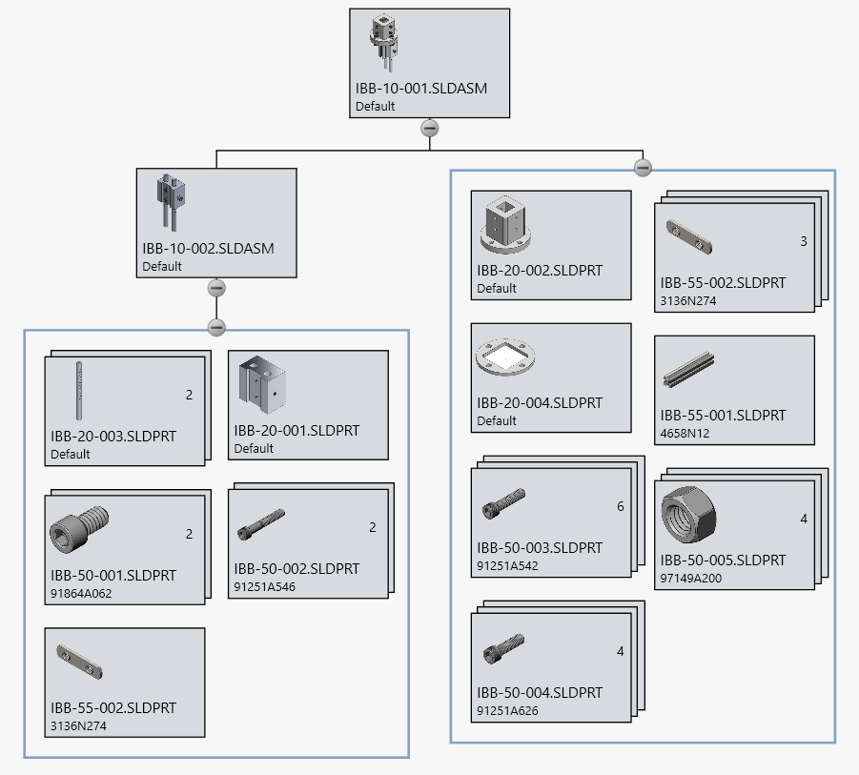
Sub-assembly Probe Standoff Mount (IBB-10-002) will be the first component of the Liquid Probe to be assembled. The Thermistor Housing Tube (IBB-20-003) stick-out distance from the Thermistor Tube Clamp (IBB-20-001) can be set arbitrarily and readjusted once the full Liquid Probe Mount (IBB-10-001) has been assembled. The Liquid Probe Mount will be constructed second, and the Probe Standoff Mount Assembly will be the last component mounted. This order of construction is not vital to the function of the probe. The Standoff Mount should be built first because it has the most function and greatest need for accuracy. The Probe Mount only acts as a mounting structure and will be built following the guaranteed function of its sub-components.
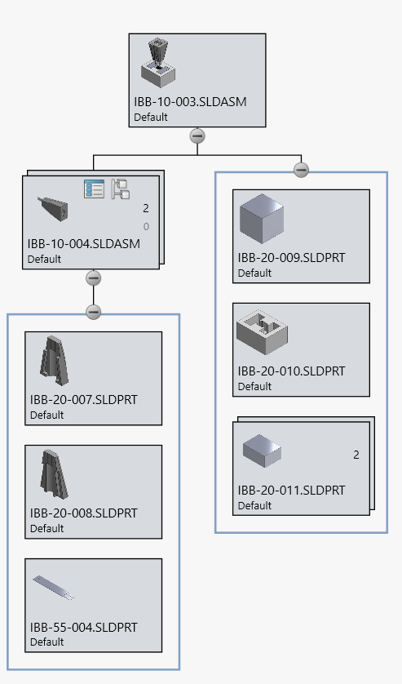
Assembly IBB-10-003 will be the solid sample from Appendix A-24E & A-25E cut into a one square centimeter cube and a stand to hold it in place. The Solid Probe Tip (IBB-10-004) will be a sub-assembly, of which two will be necessary. These assemblies will be constructed last. All components which need to be manufactured will be 3D printed. The most critical component of this assembly is the sample cube (IBB-20-009) size. The size doesn’t need to precisely be a cubic centimeter for measurement, but does need to be this size to fit within the sample holder (IBB-20-010).

iii. Parts
3D Printed Parts:
- Liquid Probe Sample Container Mount (IBB-20-002) – Print out of PLA+ filament on Makerbot Method printer
- Container Lid Pinch Clamp (IBB-20-004) – Print out of PLA+ filament on Makerbot Method printer
- Control System Container Lid (IBB-20-005) – Print out of PLA+ filament on Creality printer
- Control System Container (IBB-20-006) ) – Print out of PLA+ filament on Creality printer
- Thermistor Clamp (Male Side) IBB-20-007) ) – Print out of PLA+ filament on Makerbot Method printer
- Thermistor Clamp (Female Side) (IBB-20-008) ) – Print out of PLA+ filament on Makerbot Method printer
- Solid Sample Holder (IBB-20-010) ) – Print out of PLA+ filament on Makerbot Method printer

Machined Parts:
- Thermistor Tube Clamp (IBB-20-001 ) – CNC machined on Milltronics VM15 out of aluminum
- Thermistor Housing Tube (IBB-20-003) – purchased from supplier, slots milled out on Partner knee mill, hole bored to ensure concentricity on HAAS TL-1
- Container Lid Pinch Clamp (IBB-20-004) – CNC machined on Milltronics VM15 out of aluminum
- Solid Sample (IBB-20-009) – hand or CNC machined based on what is needed to shape material into cubic centimeter

Purchased from Fastener Supplier:
- 7/16” X ¼”-20 Socket Head Cap Screw (IBB-50-001) – purchase quantity 2
- 1.5” X ¼”-20 Socket Head Cap Screw (IBB-50-002) – purchase quantity 2
- 1” X ¼”-20 Socket Head Cap Screw (IBB-50-003) – purchase quantity 6
- 1.25” X 3/8”-16 Socket Head Cap Screw (IBB-50-004) – purchase quantity 4
- 3/8”-16 Hex Nut (IBB-50-005) – purchase quantity 4
- End-Feed Double Nut (IBB-50-007) – purchase quantity 4

Purchased from Supplier:
- T-Slotted Framing Rail (IBB-55-001) – purchase 6” length. If not available, purchase 12” length and cut down using Hogue 107 horizontal saw
- Ultra Thin 10K Thermistor – B3950 NTC (IBB-55-005) – purchase quantity 2

iv. Manufacturing Issues
All parts which will use Hogue resources to be manufactured have a degree of risk. Using machinery, such as CNC machines and mills, is only possible between the hours of 8:00 am – 5:00 pm when a lab technician is available. There is also no guarantee that these machines will be operational when the time comes that they are needed, and no guarantee they will be fixed in time if they break. If machines are not available, then it may be possible for all parts to be 3D printed. If this becomes necessary, Hogue has 4 printers which MET students can access and at least 1 machine tends to be available for use.

Another issue is that some of the purchased parts may not be available. This is most likely for IBB-55-001, which is a 6-inch length of T-slot aluminum extrusion. These are commonly sold in 12-inch lengths or longer but not typically sold at the desired length. If this length is not available, then a 12-inch-long bar should be purchased and cut to the desired length.

v. Discussion of Assembly

4. TESTING

Introduction
The goal of testing will be to ensure that Requirements 6-8 are met. Four materials will be tested, which are as follows:
- Water OR 1% gelatin + 99% water (weight percentages) at room temperature
- Water OR 1% gelatin + 99% water (weight percentages) at a temperature below room temperature and above freezing
- A potato OR apple OR sausage at room temperature
- A solid listed in Appendix A-24 or A-25 of the Cengel Thermal-Fluids book, at a known temperature
Materials 1 and 2 will be used to test the liquid probe, while Materials 3 and 4 will be testing the solid probe. Per the requirements, successful testing means that the TCM will have measured the thermal conductivity of these materials within 5% accuracy and 15 minutes per measurement, with a material preparation time not to exceed 45 minutes.

Assuming the TCM is built well and the electronics work, it will be easiest to hit the 5% accuracy threshold in a liquid environment. The probe tips will be small enough and the liquid will be voluminous enough so that there will be few losses caused by the experimental environment. For similar reasons it will be harder to accurately measure solids. Solid materials may not conform to the shape of the probes and need to be smaller for easier preparation and handling in the testing. There will be more environmental factors at play on the surfaces of the solids which will need to be made up for.

Further testing of the TCM would involve its electrical system. Analysis 5 concluded that the potentiometer in the Wheatstone bridge should be set to 5 kΩ of resistance to balance the bridge at room temp. The potentiometer will frequently be used while calibrating the machine, so testing this calculation is relevant.

b. Method/Approach
Water will be the most likely choice for both Materials 1 & 2, since controlling it for temperature will be simpler than controlling for gelatin mixture and temperature. The vessel holding the liquid will be a standard, large jar. The assembly holding the liquid probe is designed to fit on a standard jar lid. This allows for easy test set-up and a technically boundless environment for the probe to measure. One consideration to take is how the liquid within the jar will be able to maintain a constant temperature above or below room temperature.

Since Materials 3 and 4 are solids, they will be more difficult to test. Both materials will need preparation, which will involve cutting them into two equal, uniform pieces which one of the solid probe’s leads can be sandwiched between. Insulation around the materials and probes will be necessary to get the best possible measurement. Copper, carbon steel, and aluminum are the easiest materials to access from the Cengel Appendices and are the most likely to be measured.

Whether liquid or solid, both measurements will be set up similarly. One thermistor will be dipped/sandwiched in the material. Another thermistor will be a measured, constant distance away. At the start of a measurement, the former thermistor will be joule heated over a measured amount of time. Both the power and time will be recorded by the TCM. The latter thermistor will be used to record change in temperature over time. Plugged into Excel and factoring in the distance apart, these values will be used to calculate the thermal conductivity of the material. The time and power needed to get an accurate measurement can be modified depending on the material.

If the TCM can give precise measurements, they are very likely to be inaccurate. This may be due to any number of factors; therefore the machine will need to be calibrated towards an accurate measurement. Once a large pool of measurements has been gathered, the average “error factor” can be found and compensated for to reach the 5% accuracy requirement. Both probes will have their own error factors.

c. Test Process

d. Deliverables

5. BUDGET

a. Parts
Electronic components, mechanical components, and materials will each be acquired from different vendors. Electronic components will come from Adafruit, Arduino, Digikey, or Jameco. Since this proposal coincides with many seasonal sales, hobbyist-orientated vendors (namely Adafruit) will be used to purchase components at a lesser cost. Any electronic surplus will be sold to Isayah Bannister at cost.

Mechanical components will be bought at McMaster-Carr. Materials, which include aluminum stock and 3D printer filament, will be sourced from Amazon or a similarly timely vendor.

b. Outsourcing
All assembly will be done using CWU MET department resources, including workspaces and machinery. Some electronic components may be purchased pre-assembled, but the system will be assembled and soldered in-house.

c. Labor
Labor will be sub-sectioned into electrical assembly labor, mechanical assembly labor, and component manufacturing labor. Mechanical assembly labor hours will be low, as the TCM mostly consists of electrical construction. Component manufacturing labor will include hours spent manufacturing by hand as well as hours of machine time. Machine time will only be factored in if machine troubleshooting or maintenance becomes necessary. Isayah Bannister will be responsible for all labor, which will be billed at the same hourly rate as for a CWU MET department student lab technician.

d. Estimated Total Project Cost
The current total project cost is estimated to be $662.88. This includes all part costs, labor, shipping, taxes, and time on machinery. The largest expense is labor, which totals $339.03 after taxes. This is followed by the parts cost, which is $210.73 after taxes. The maximum allowable project budget is $1000, which is closer to resembling the retail cost of currently retailed thermal conductivity testing machines.

e. Funding Source
The majority of this project will be funded by Isayah Bannister. Components which also could be useful in the MET314 and MET316 labs may qualify for funding from the CWU MET Lab budget, per review by Dr. Choi and William Reichlin. Further CWU resources that will be used include access to 3D printers and machining equipment.

f. Winter Updates
fa. No electrical components were purchased from Digikey or Jameco. All were purchased from Adafruit, except the Arduino which was bought direct from Arduino.com. The Adafruit website is much more convenient to purchase components on than the former two sites. They are targeted towards hobbyists and beginners, while the former market towards customers more knowledgeable in electronics. The prices for components were similarly cheap, so the budget was not affected.

fb. All labor and manufacturing have remained in-house. Wire strippers were purchased for use since there were none in the machine shop tool inventory.

fc. Plans to produce components using the Milltronics CNC machine were eliminated. All components are to be made with a 3D printer. Previously, machine downtime was billed at $16.66/hr and 0.5 hours were planned. This would have been time spent on machine maintenance. Following the updated manufacturing method, this time will now be treated as time spent running the 3D printer. When a printer is busy, it cannot be used for that period of time, hence billing as machine downtime. This only includes time spent by a printer producing a part. This time is billed at $5.00/hr, since the machine can run autonomously overnight and needs no human oversight.

The wage of an MET Student Lab Technician has risen alongside Washington State minimum wage to $17.13/hr. This project will not take this into account and continue billing human labor time at $16.66/hr.

fd. The updated expected budget is $854.19. This still remains under the $1000 maximum project budget.

fe. All components were purchased with funding from Isayah Bannister. No further expenditure is expected.

g. Spring Updates

6. SCHEDULE

a. Design
Fall:
The Project Proposal, all analysis, and all component and assembly drawings are to be completed in Fall quarter. The final submission date for the proposal with all Fall Quarter tasks completed is December 10, 2025.
All analyses should be completed by November 29 to allow enough time for final submission. To meet this date and allow enough time for any extra analysis or reworks, at least two analyses should be fully completed every weekend. As stated in Appendix E, the scheduled time for these analyses is two hours per analysis, with two completed every Saturday.

Winter:
Prior to construction, all component drawings should be reviewed. 3D printing will take a large amount of time which should not be afforded for parts which haven’t been thought through. For each design revision, the drawings will have to be redone accordingly. As of 33% construction completion, all components pertaining to the Container have been revised.

b. Construction
Winter:
The Thermal Conductivity Meter will consist of three complex parts. To guarantee their function, the construction of each part will not overlap with another. The order which they should be assembled in will be the Electrical System, the Liquid Probe, the Solid Probe, and the housing for the Electrical System. The completion of these assemblies should coincide with the due dates for 33%, 66%, and 100% construction completion. The scheduled time for this can be seen in Figure E3. As can be seen in the same figure, the manufacturing time for each component is not pre-scheduled. Time on component manufacturing will be logged as necessary whenever a component is worked on or completed. The goal of this freedom is to hopefully relieve some pressure while still maintaining targeted due dates for completion levels. 33% of construction was successfully completed by the due date, but the drawings had not been fully revised by Jan 23. If it becomes necessary, drawings and SolidWorks part revisions should become rigidly planned and scheduled.

c. Testing
Fall:
The electrical system of the TCM requires some electrical engineering knowledge which goes beyond the course material in Basics of Electricity (EET221). It is possible that time in the EE laboratory testing some circuit arrangements could become necessary to make sure sound analyses are being conducted. Should this need arise, time must be allocated in the Gantt chart located in Appendix E.

Spring:
The TCM will need to be tested using the four required test materials. Each material should be tested at least twenty times to get the most accurate average reading possible. Currently, three hours have been allotted for each material. As many tests as possible should be conducted in this time, and more time can be allotted if necessary.

7. PROJECT MANAGEMENT
Controlling the risks of this project will be an exercise in scheduling and productivity. Most of the resources utilized will be localized in the Hogue Technology Building and therefore be subject to the same hours of availability. This creates risk of unproductivity and unavailability. Project success will be determined by the amount of work which can be effectively done while Hogue resources are available.

a. Human Resources
Human resources associated with this project include several MET Department staff members in CWU’s Hogue Technology Building. The primary contacts for project advising will be Professor Pringle and Dr. Choi. Their best availability for to give advising will be during MET489A/489B/489C. Contact during any other time will primarily be over email. Should any in-person advising be needed, Professor Pringle is most likely to be the main point of contact.

William Reichlin is the project resource for access to materials and machinery. If any Hogue building 3D printers, machinery, or stock from Room 107 are to be used, then he should be contacted. This project benefits from a prior established professional relationship with William. If needed, he can be contacted via email or Microsoft Teams 8:00 AM – 5:00 PM any day of the week, but he can only assist with Hogue resources during weekdays.

b. Physical Resources
Most components manufactured for this project will need to be produced using a 3D printer. Printers available to use in the Hogue Technology Building include two Makerbot Methods, one Method X, a AnyCubic Kobra Neo 2 and a Creality printer. Between these printers are the capabilities necessary to make parts which fit within a square foot out of PLA, ABS, TPU, or PETG filament. Available resources which will be accessed in Hogue Room 107 include a Milltronics VM17 CNC mill, a Haas lathe, and a Partner milling machine.

Any components which require turning or can be machined within 3-axes will be produced using these machines. Availability of all machines in Room 107 or the 3D Printers is subject to predetermined hours of availability. These hours will change quarterly and are affected by the availability of a student lab technician, who must be present while these resources are being used. Any usage requires scheduling around lab tech hours.

Furthermore, all machines in Hogue have an associated hazard. CNC machines, mills, and lathes can seriously injure the user if safety precautions are not taken. PPE and knowledge of how to safely operate the machine will be required prior to using any resource in Room 107. 3D printers operate using a hot extruder, so caution around handling a printer which is in use will be taken.

Other less consequential resources which will be used include various hand tools (screwdrivers, wrenches, etc.), a multimeter, an oscilloscope. and soldering equipment. Hand tools can be accessed in Room 107, while electrical measuring and soldering equipment will be accessed in the EET Labs. Soldering availability depends on when the labs have open hours and an EET lab technician is available. Soldering produces extreme heat and noxious fumes, so proper ventilation and caution will be used while soldering.

Any injury incurred while using equipment or machinery during this project is unacceptable. Since many machines, especially in Room 107, are quicker to produce catastrophic harm than a simple cut or burn, then the margin for error across all equipment used is zero. Any injury will mean no further work with that equipment will be done, an accident report will be written, and a safety evaluation will be carried out.

c. Soft Resources
Software resources used in this project include programs used for component drawing/manufacturing, analysis completion, and resource gathering.

WordPress is the website host and building platform used to showcase the development of this project. Risks associated with using the platform include its learning curve and prior lack of knowledge in website development. The risk of potentially being unable to develop a website for this project is mitigated by the various tools WordPress offers that help make it straightforward to construct all the necessary webpages.

All CAD/CAM resources and Microsoft Project will only be accessible from a Hogue computer. These include SolidWorks, SolidCAM, MasterCAM, and potentially others. Any work involving these programs needs to be scheduled around Hogue computer lab hours.

Online research resources, including textbooks and MDSolids, can be accessed any time from any computer. PDF files of needed files can be easily found and downloaded online. Textbooks purchased during prior academic quarters can also be accessed through Canvas.

d. Financial Resources
The project sponsor will commit any monetary support for expenses incurred during the project to a maximum of $1000. The CWU MET Department may be willing to provide up to $100 of grant money sourced from MET314/315/316 student lab fees.

Expenditures which result in the project going over budget would strongly contrast with the original project intent; part of which is to remain as inexpensive as possible. Overspending would also seriously impact the financial standing of the sponsor and block opportunities to invest resources in other projects

8. DISCUSSION

Design
Throughout the design phase of this project, the original vision hasn’t deviated far from the current iteration. The design vision has remained as a computing system, a probe/system for measuring liquids, and one for solids.

Design changes to the control system are most likely to take place in winter quarter during the construction phase. Since the project lacks anything more than basic electrical engineering expertise, the best way to determine system flaws will be to prototype and test it in the construction phase. The same goes for operating the Arduino board. System functions such as precise heat delivery to the probe, measurement displays, and transforming the thermistor readings into a thermal conductivity value will need to be programmed into the Arduino. Lack of programming knowledge is a deficiency that would afflict the project no matter what microcontroller board was used. Developing proficiency in operating the Arduino will be a project focus during the construction phase.

At first, the liquid probe was planned to apply the transient hot wire method, which uses heat applied across a thin wire and temperature recorded by an adjacent thermistor. A design matrix was used to choose between various probe arrangements, and the twin thermistor arrangement scored superior to the transient hot wire. Since that point, all design decisions have been made assuming twin thermistors. The liquid probe mount has gone through a few changes that make it more sensible as a usable, manufacturable assembly. Originally, the Thermistor Tube Clamp and Thermistor Housing Tube (parts IBB-20-001 and IBB-20-003 respectively) were one part. The change was made to break them up into two different parts which made up an assembly. As one part, this part would have been exceedingly difficult to manufacture well. As two parts, many more options are available for CNC machining or 3D printing one or both. The Control System Container (IBB-20-006) used to be a side-panel for the control system case. The case would have been made up of 5 individual pieces which would be adhered together into a rectangular box and combined with a Control System Container Lid (IBB-20-005). These parts were planned on being 3D printed, and since this was the case, it ultimately made more sense for the box to be printed as one piece. This cut down on wasted time designing a box piece by piece and risk of the box not fitting together. The new box was designed to fit with the lid which was already designed. The last changes to the design were to change or eliminate some threaded holes. IBB-20-001 and IBB-20-002 originally had more threaded through-holes than their current version. Any threaded hole which featured a screw reaching for an exterior fastener was changed to a plain through hole, since the threads were unnecessary and added manufacturing complications. Two holes were also completed removed from IBB-20-002. This was done so that the thermistor wires could be snaked through the T-Slotted Framing Rail (IBB-55-001) and reach through IBB-20-003, which can be visualized by observing the Liquid Probe Mounting Assembly (IBB-10-001).

The solid probe has undergone no changes since the project began. One cause for this is that the liquid probe was determined to be the primary project focus aside from the control system. Given the expected project workload and lack of academic expertise in heat transfer, the project goal was interpreted as to develop a functioning liquid probe first and foremost, and a solid probe afterwards. Another cause for the lack of change is that there has not been much opportunity for change thus far; the solid probe requires much fewer parts than the liquid probe. The liquid probe must account for maintaining distance and depth of the thermistors while adapting to a liquid-containing vessel. Meanwhile, these factors are all determined by the shape of a solid. If there is further work to be done on the solid probe, it would be to develop a sample holder and insulation surrounding it. As of the time of writing, this has not been done. As the probe currently stands, if the thermistor tips are properly fixed to the sample and heat sufficiently, then it is likely that thermal conductivity can be found somewhat accurately.

b. Construction
Continuing into Winter quarter, much of the TCM as it is being constructed resembles the original design. Components that have undergone the most iteration are the various parts to contain the electronics. In Fall, the container was originally conceived as a six-panel box which would unite with indexing tabs. At the end of the quarter, it was an open-top box with a lid which all the interactable components attached to. Now, in Winter quarter, the container is three components: the Container Lid (IBB-20-005), the Container (IBB-20-006), and the Front Panel (IBB-20-012). The Front Panel will have most of the interactable buttons and switches, while the Lid will have the LCD displays.

Another change which occurred is the switch to using PETG filament for all 3D printed parts. This strays from the decision matrix pictured in Figure F4 which found PLA+ to be the best choice. The main reason for this was further research into the long term longevity of PLA-printed parts. Due to the chemistry of the filament, PLA parts will all inevitably disintegrate. ABS filament will not do this, but is difficult to print using Hogue resources. Alternatively, PETG filament is a middle ground between PLA and ABS in terms of temperature stability, chemical stability, and strength. By chance, the AnyCubic Kobra 2 Neo printer in the MET Lab Tech office was found to do an excellent job at printing PETG filament. As a result, 2 kg of PETG was purchased and has been used to print all necessary parts.

Other changes to the TCM since the start of the quarter have been logical extensions of other ideas. The Container will have screws threaded into it, so the threads must be strong enough to hold. Thread inserts (IBB-50-008) were added to the part’s design to account for this. The thread inserts are widely available in M3 thread sizes, and M3 screws also fit through the screw holes in the electronic components, so M3 screws were adopted for all Container assembly components. This was made convenient by the availability of M3 screw kits in the machine shop, which were left behind by MET seniors from previous years. For the Liquid Probe Assembly, it was found that designing for 1-inch aluminum extrusion meant the parts were too big to actually fit through a standard wide-mouth jar. The components, IBB-20-001, IBB-20-002, and IBB-20-004, were then adapted from 20mm aluminum extrusion. The ¼-20 screws that were used in these components were also swapped for M5 screws, since the Double Nuts (IBB-50-007) for the extrusion only came in metric sizes and M5 is dimensionally similar to ¼-20.

c. Testing

9. CONCLUSION

a. Design
The purpose of the Thermal Conductivity Meter is to create a system which measures the thermal conductivity of a given liquid or solid sample. The primary goal of this project is to engineer a system capable of this which is compact, inexpensive, and able to be used for the MET316LAB course. The requirements which this goal entails include the TCM needing to use standard wall outlet power, measurements needing to lie within 5% of reference values, weight not exceeding 20 pounds, and replacement probes costing no more than $150.

Several analyses were done to ensure the final product would meet these requirements. The turns ratio of a transformer needed to convert 120v outlet power to the Arduino’s accepted 7-12V. Wheatstone bridge balancing and characteristic length of solid sample calculations were completed. The Wheatstone bridge was found to be sufficient to power the thermistor heating element, and a characteristic length of 1 cm was found to fit within the boundaries of a lump-able system. Weight and price estimates using information provided by online retailers concluded that system weight would be under 20 pounds and probe replacements would cost less than $150.

All manufacturing and assembly of the TCM will take place in Hogue. Consideration was taken during component design to ensure all components will be feasible to. In Hogue, all physical, software, and human resources needed to create the TCM are easily accessible. Given the analyses, the part design, and project management that has been done, the Thermal Conductivity Meter is ready to begin construction with confidence that it will be effective in meeting all requirements and fulfilling its purpose.

b. Construction

c. Testing

10. ACKNOWLEDGEMENTS

This project is made possible by Professor Charles Pringle and Doctor John Choi. They provided the advising and assistance necessary to turn the idea of how to approach this project into a full project proposal which can be executed upon. They are also credited with making future work in Winter and Spring quarters possible, since their expertise will continue to be called upon.

The machinery and other physical resources that this project relies upon would not be accessible without William Reichlin.

Though the entirety of this project is a solo endeavor, it could not have been completed without the assistance of classmates in CWU’s MET senior cohort. Tylan Holmes, Carly Kahler, and Paige Henderson helped foster motivation to see this project through and provided moral which was integral to accomplishing all tasks thus far. Jace Leensvaart and Armando Nungaray provided criticism and different approaches which helped produce better designs and drawings.

References
[1] Ada, Lady, 2012, “Using a thermistor,” Adafruit Learning System [Online]. Available: https://learn.adafruit.com/thermistor/using-a-thermistor. [Accessed: 09-Nov-2025].
[2] 2023, “Transient hot wire method - the overview,” Thermtest Instruments [Online]. Available: https://thermtest.com/transient-hot-wire-method. [Accessed: 03-Oct-2025].
[3] Hibbeler, R. C., 2024, Statics and mechanics of materials, Pearson, Hoboken, NJ.
[4] Mott, R. L., Vavrek, E. M., and Wang, J., 2018, Machine elements in mechanical design, Pearson Education, New York, NY.
[5] Çengel, Y. A., Cimbala, J. M., and Turner, R. H., 2017, Fundamentals of thermal-fluid sciences, McGraw-Hill Education, New York, NY.

APPENDIX A - Analysis

Appendix A01 – Controlling Factors to Match Fourier’s Heat Conduction

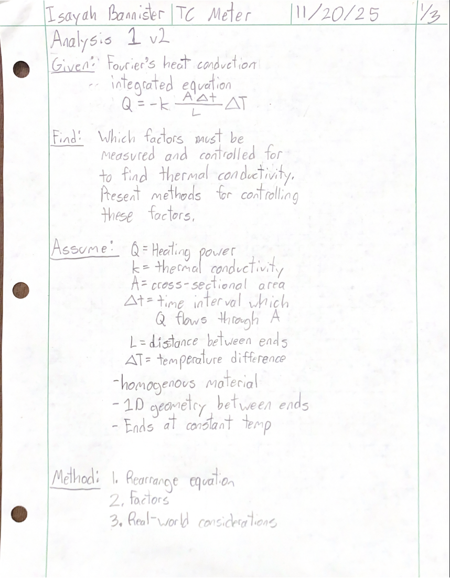
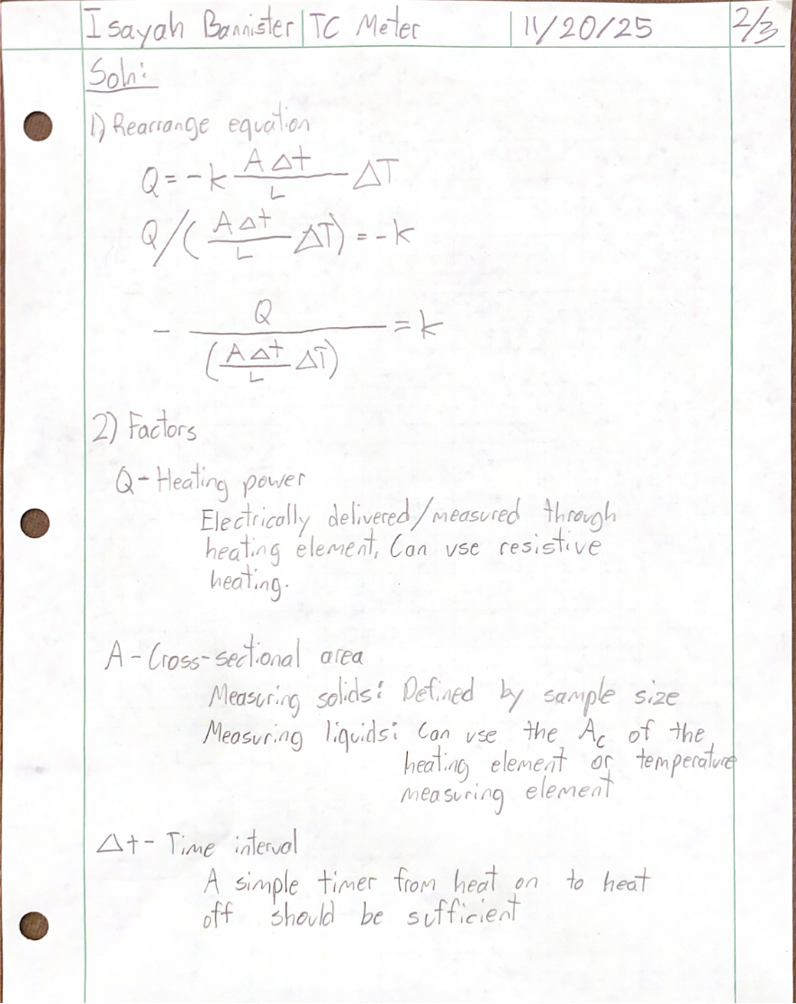
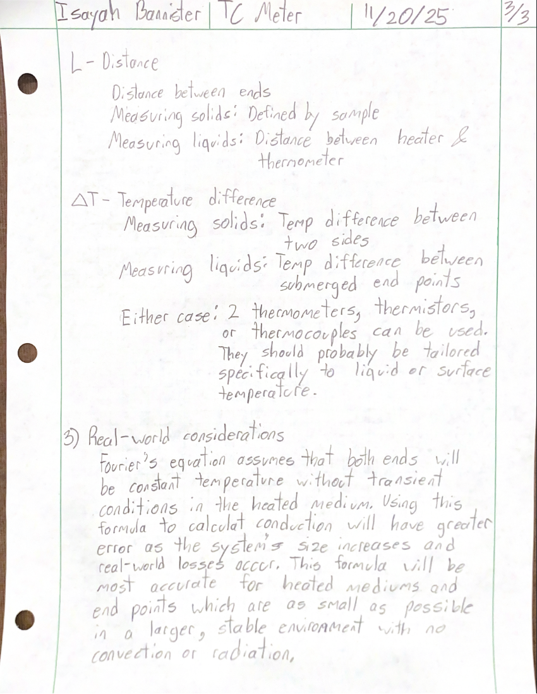

Appendix A02 – Sufficiency of Arduino Uno Rev3 Supplied Power

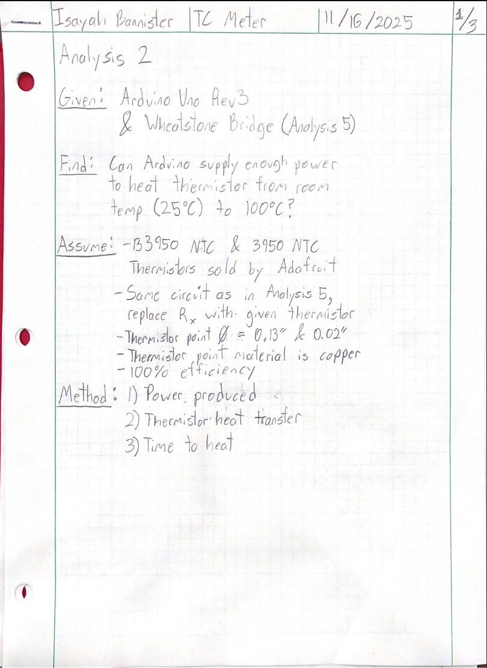
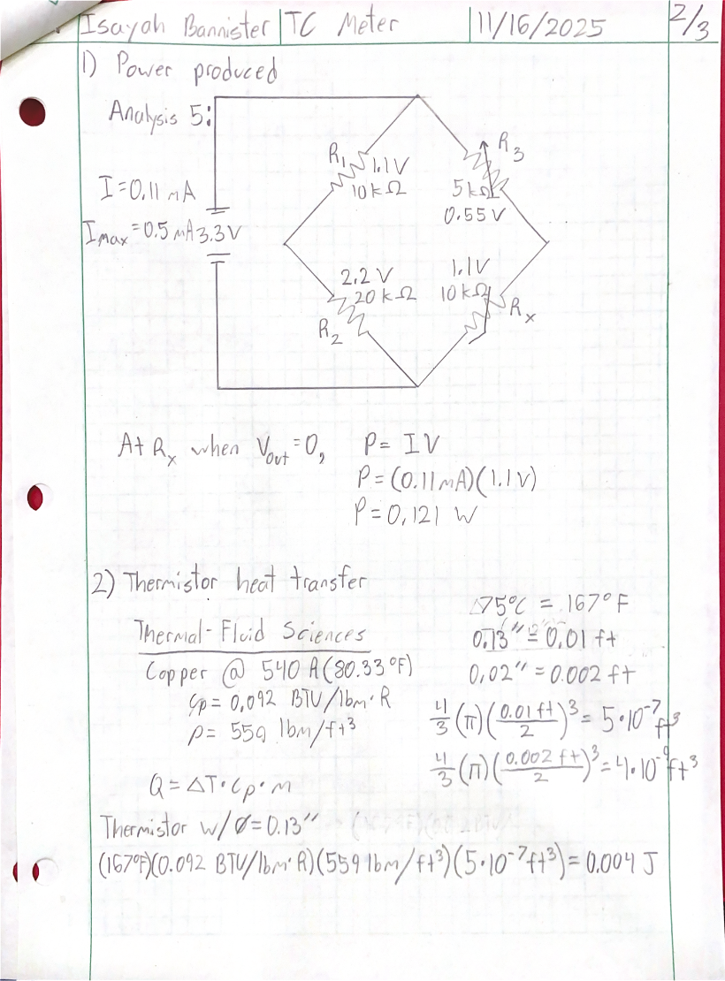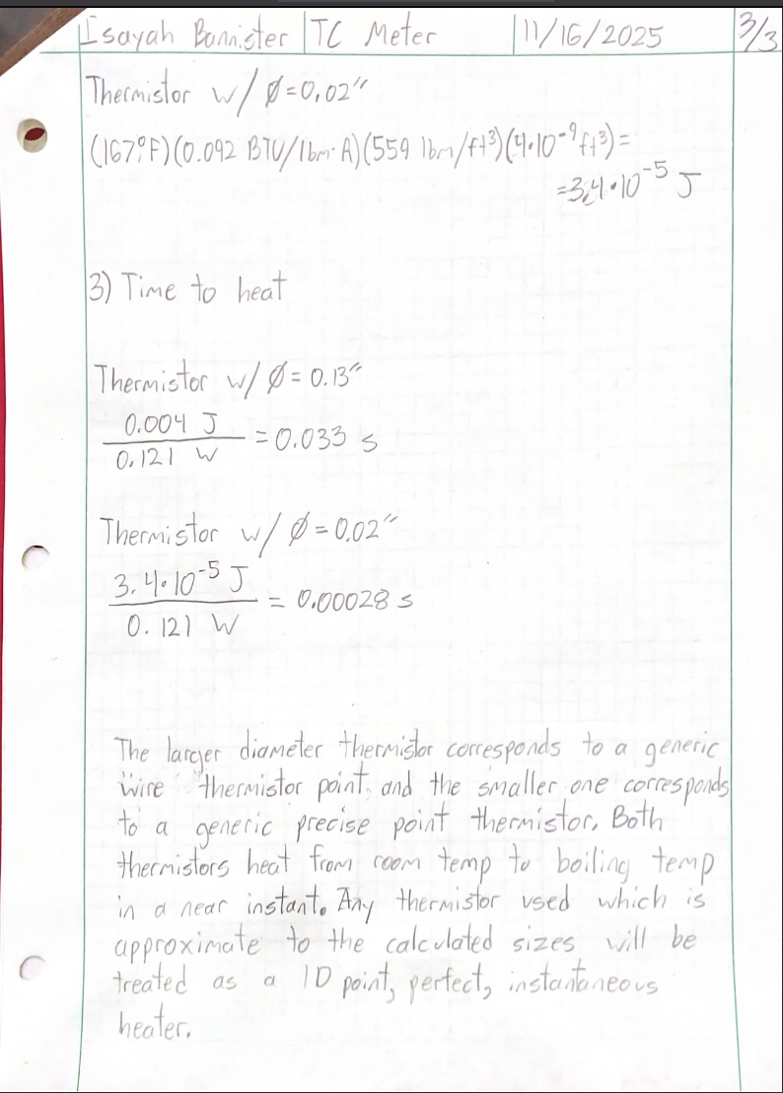

Appendix A03 – Wall-Arduino Power Transformer

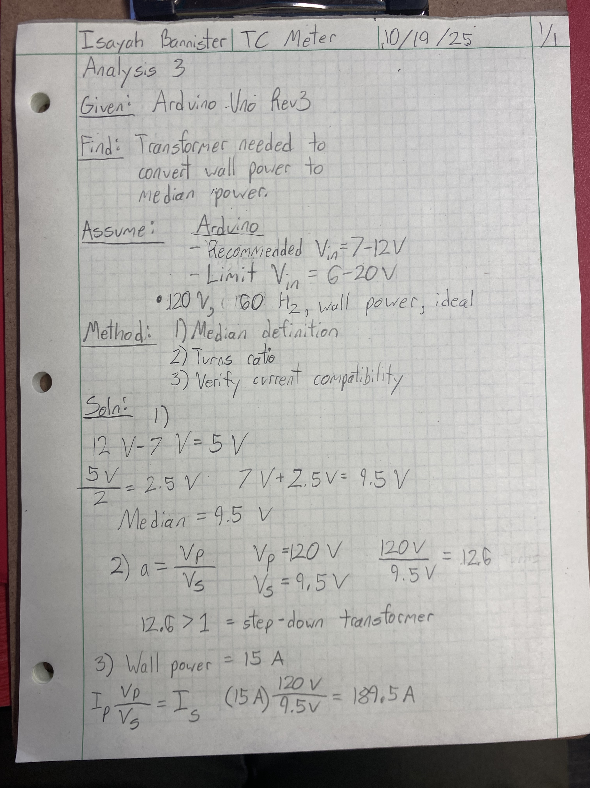

Appendix A04 – Liquid Probe Tube Deflection

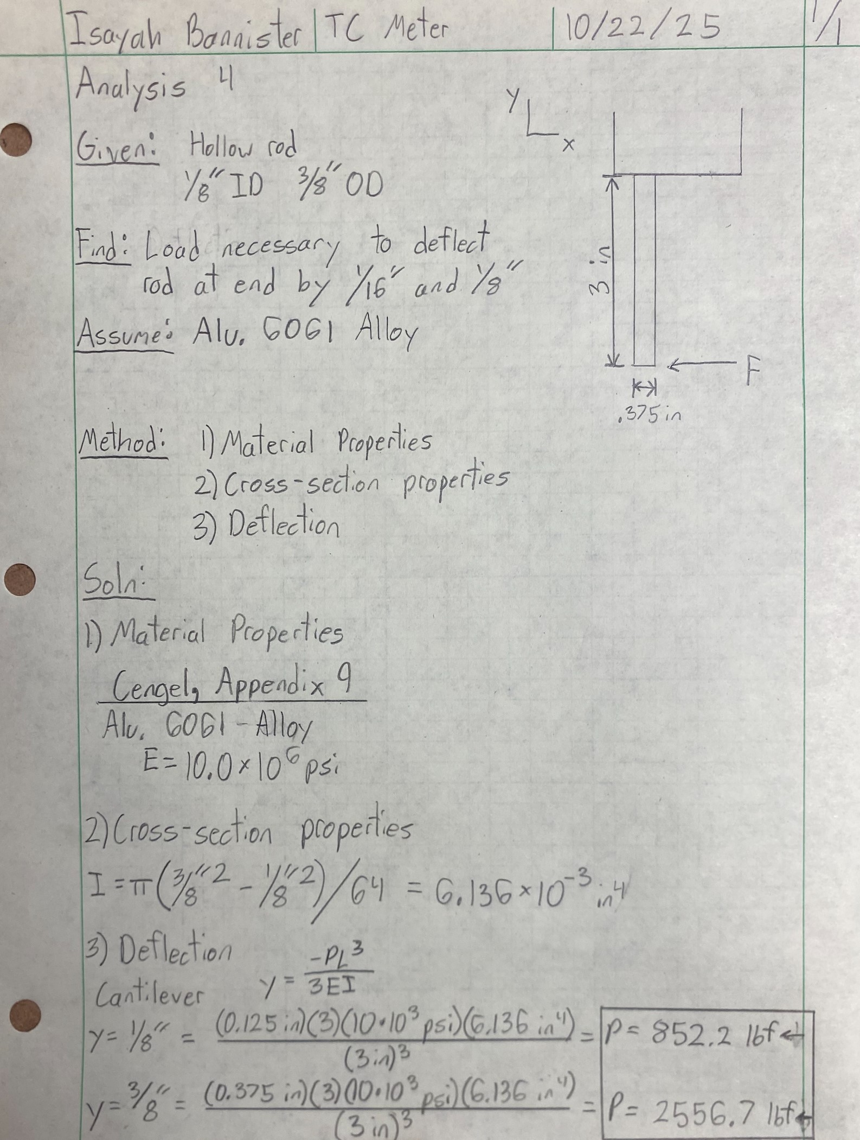

Appendix A05 – Wheatstone Bridge Balance

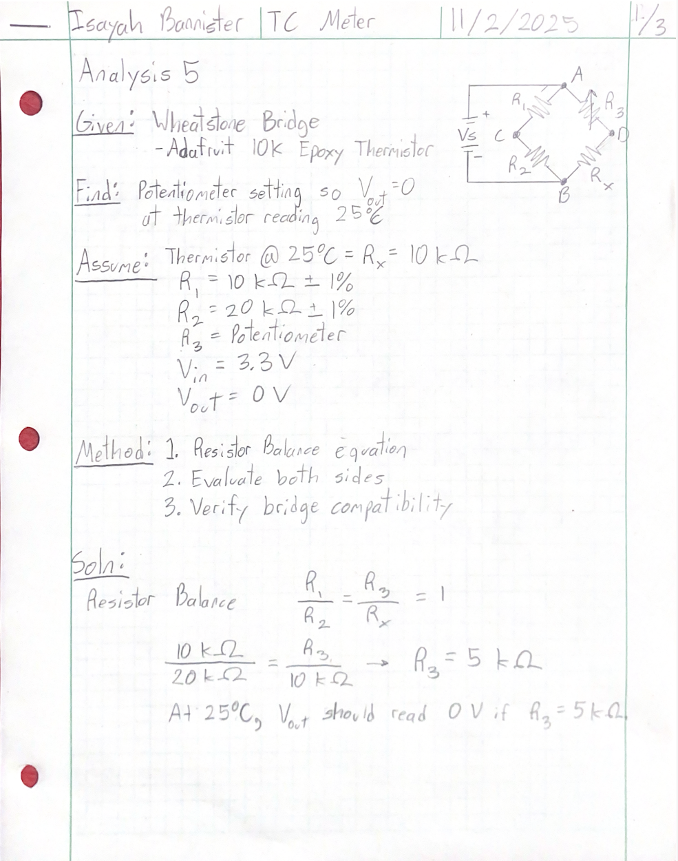
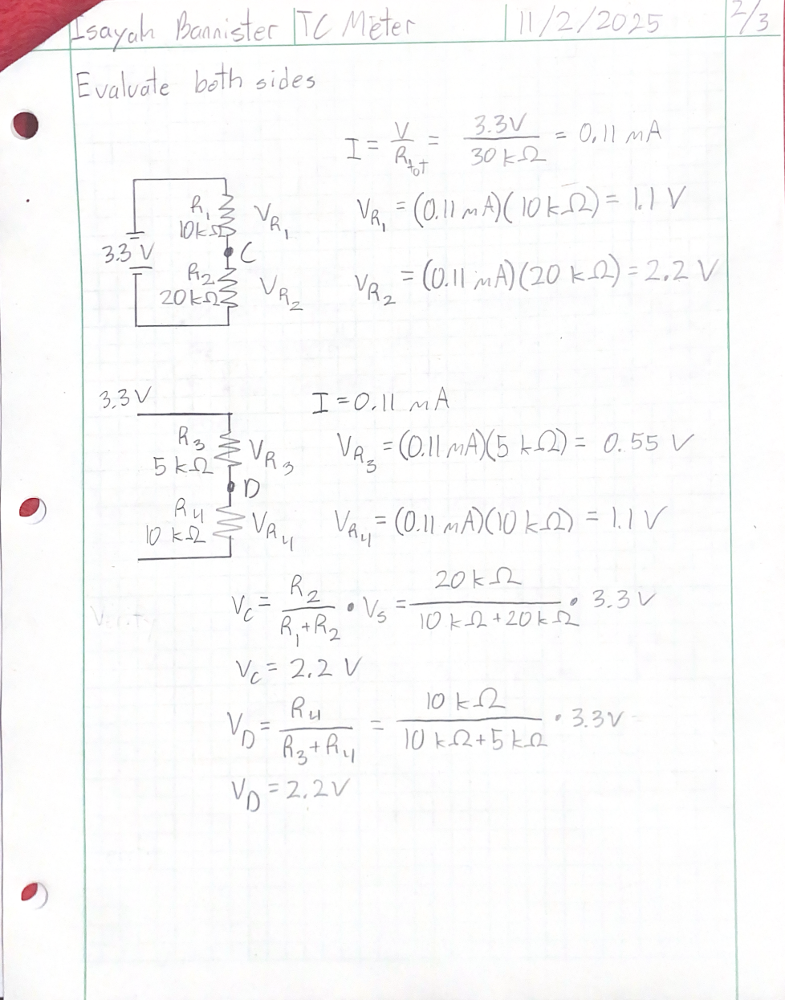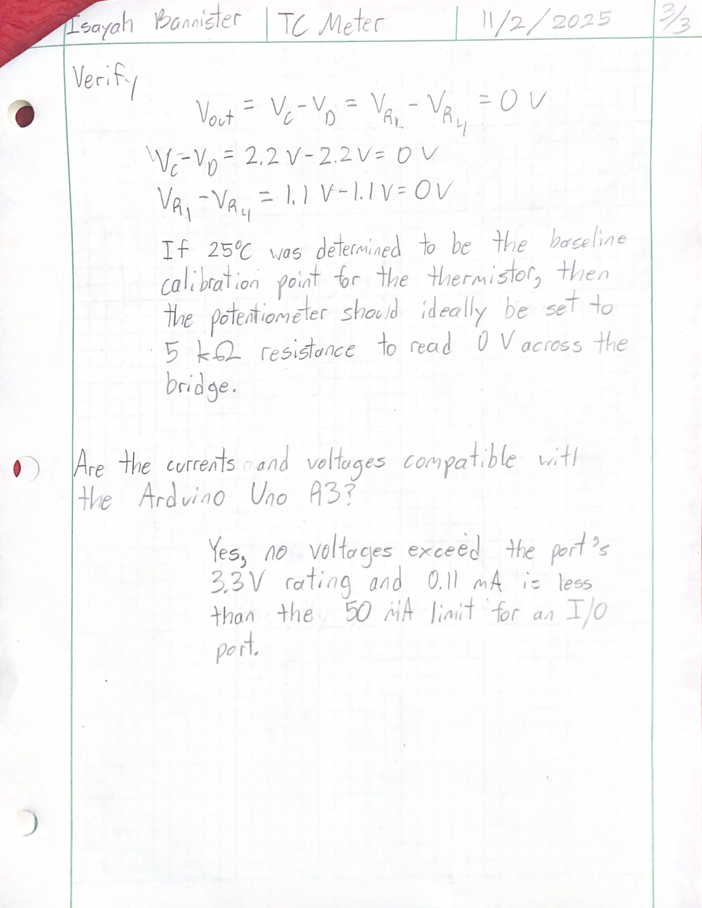

Appendix A06 – Liquid Container Lid Clamping Force

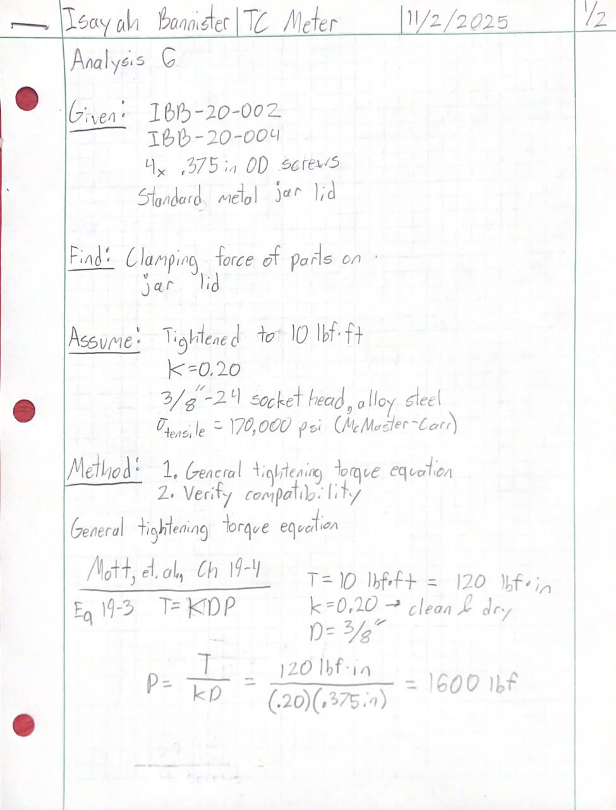
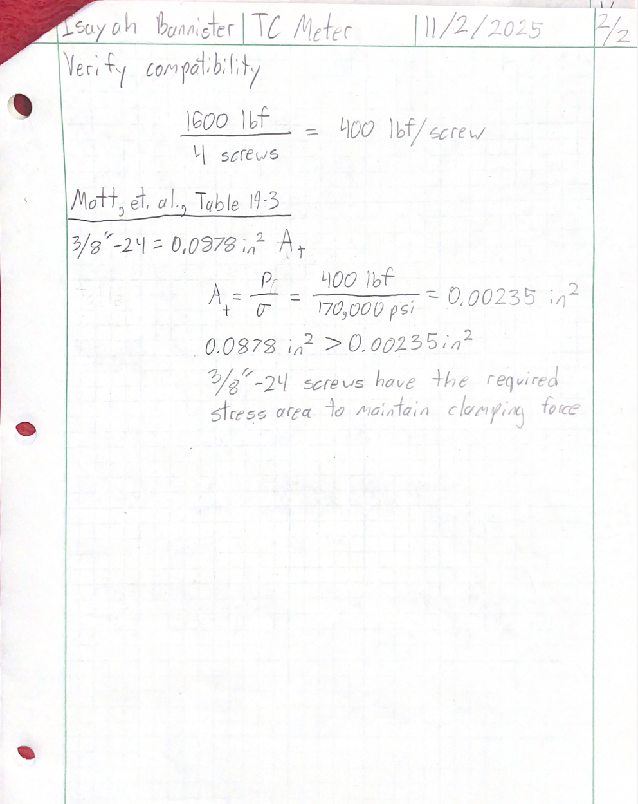

Appendix A07 – Electrical Computing System Weight

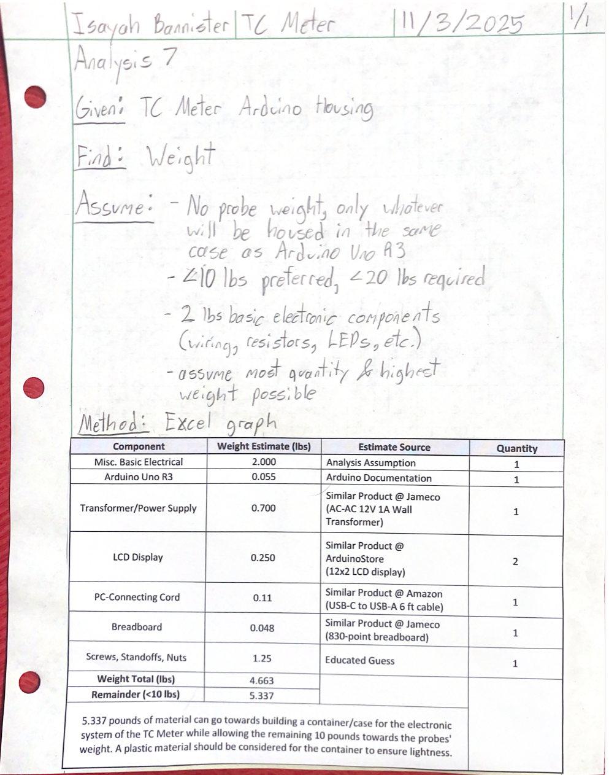

Appendix A08 – Characteristic Length of Solid Sample

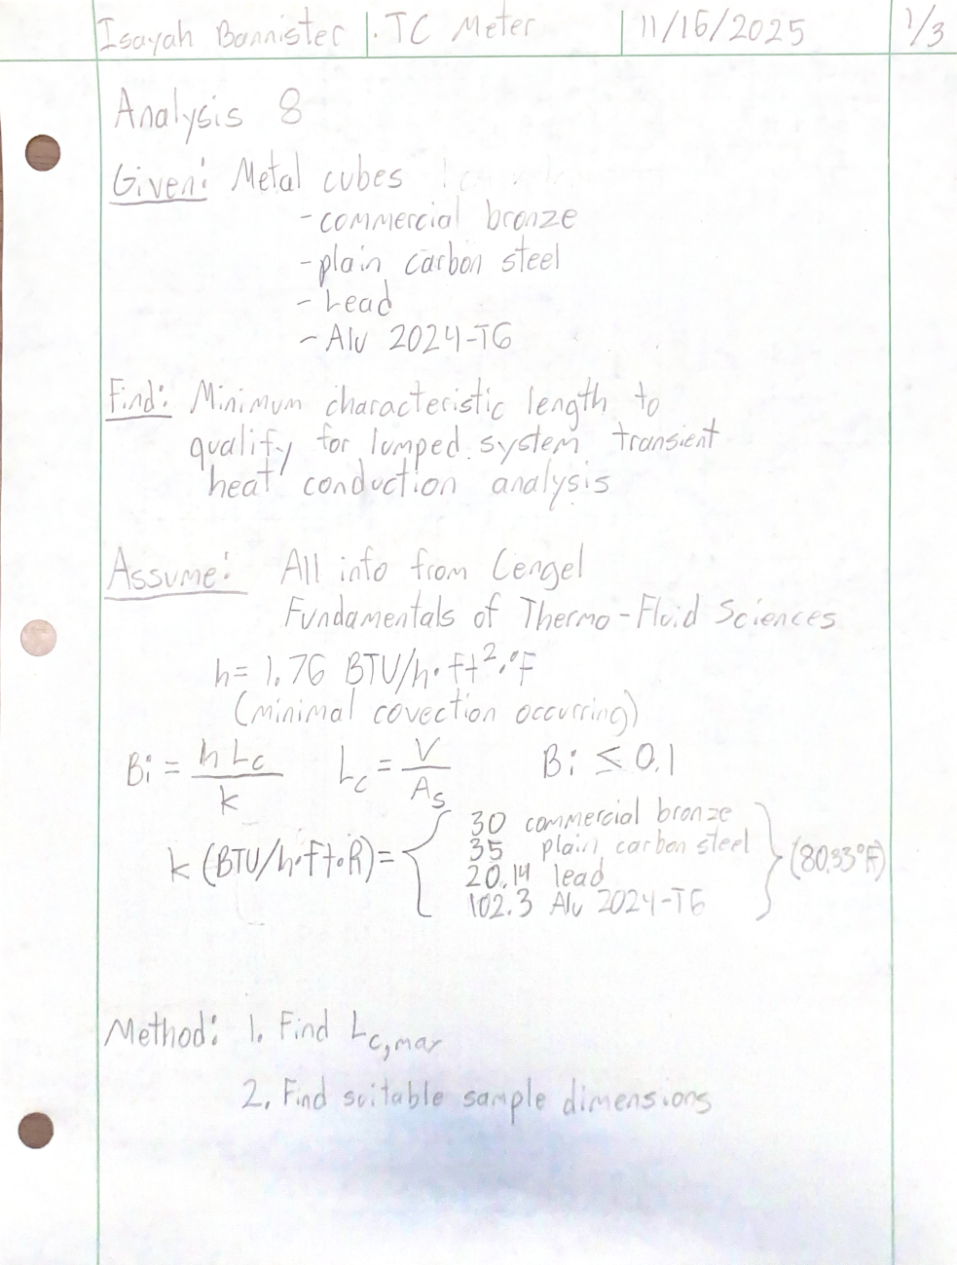
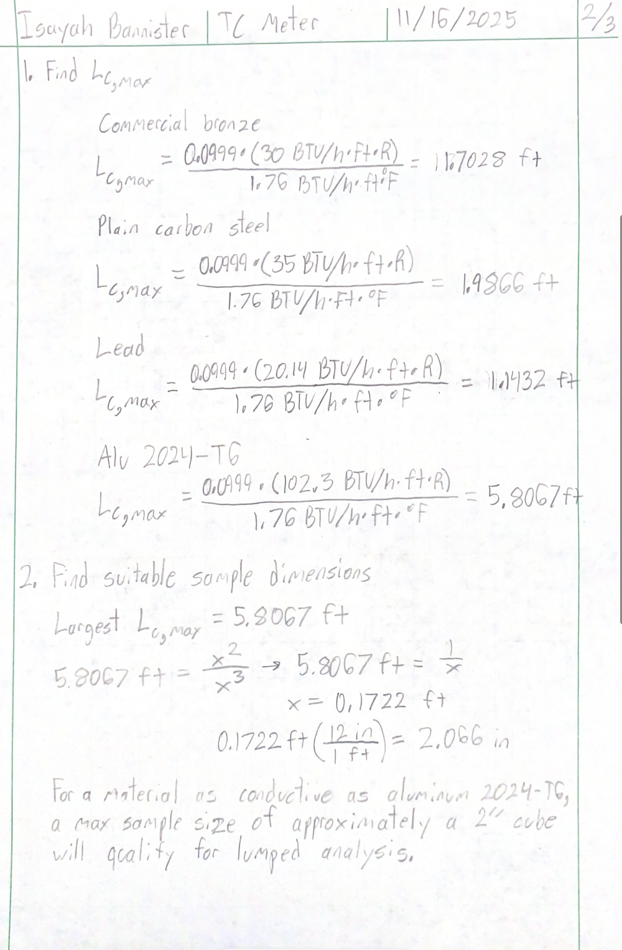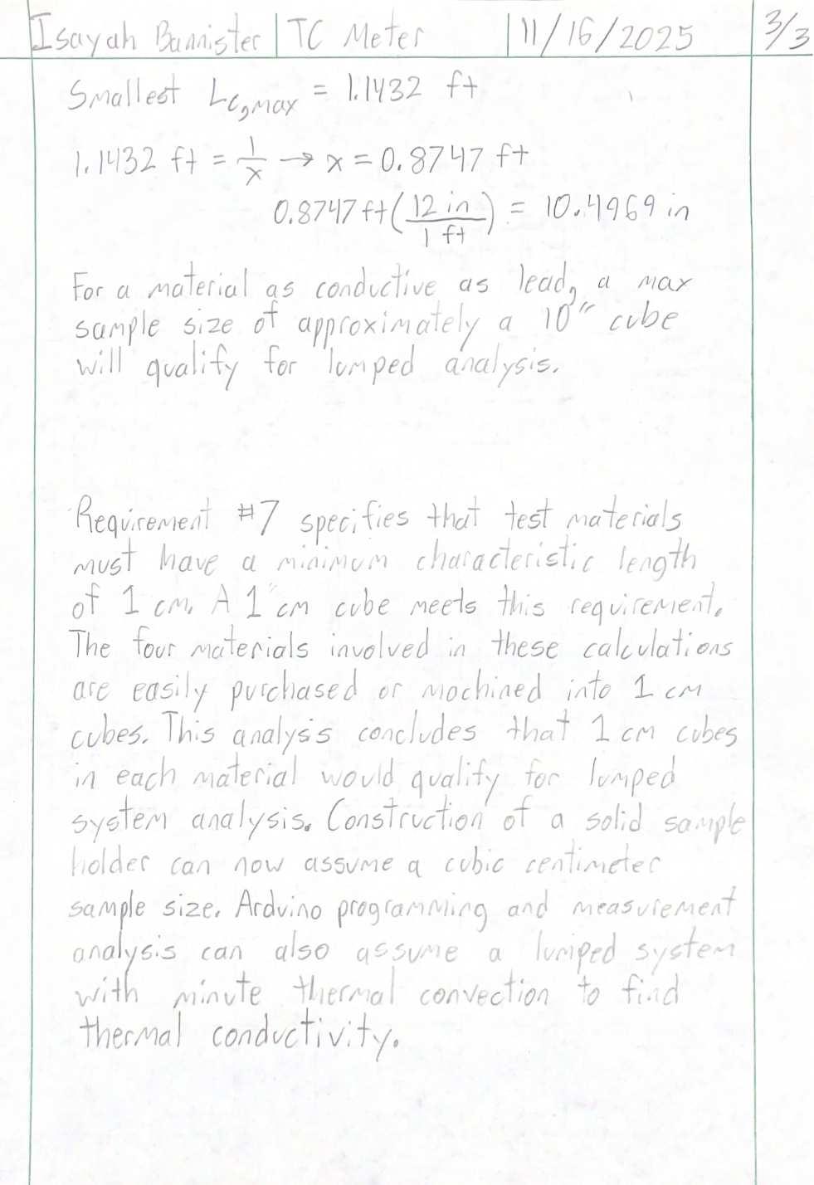

Appendix A09 – Thin-film Thermistor Bending

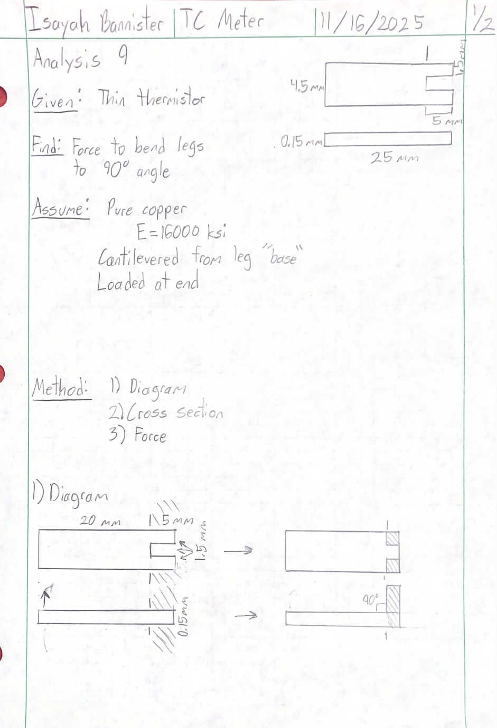
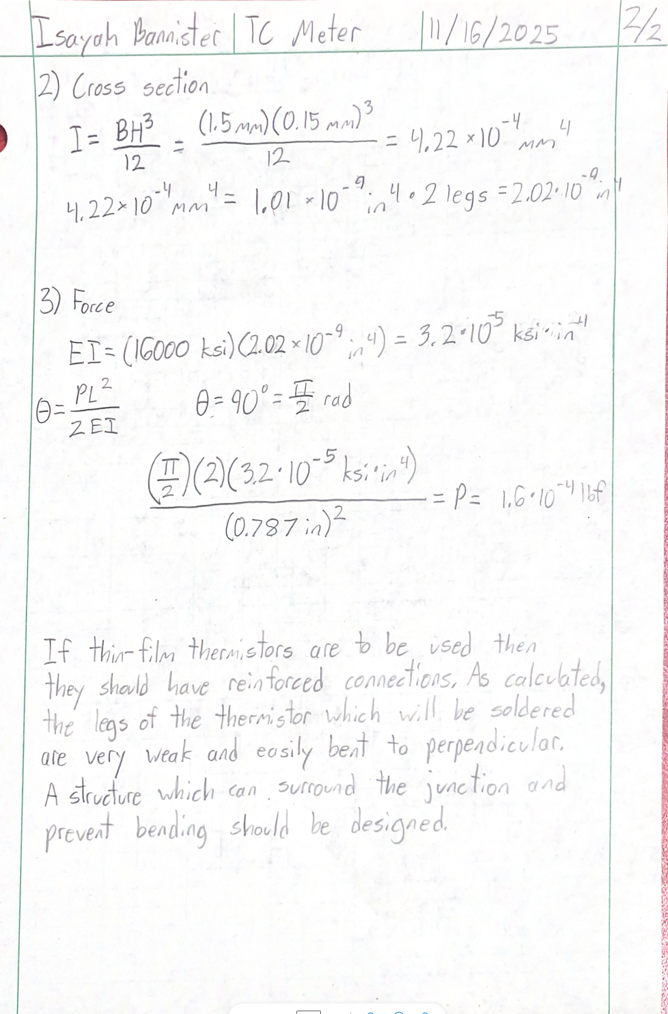

Appendix A10 – Total Power Drawn

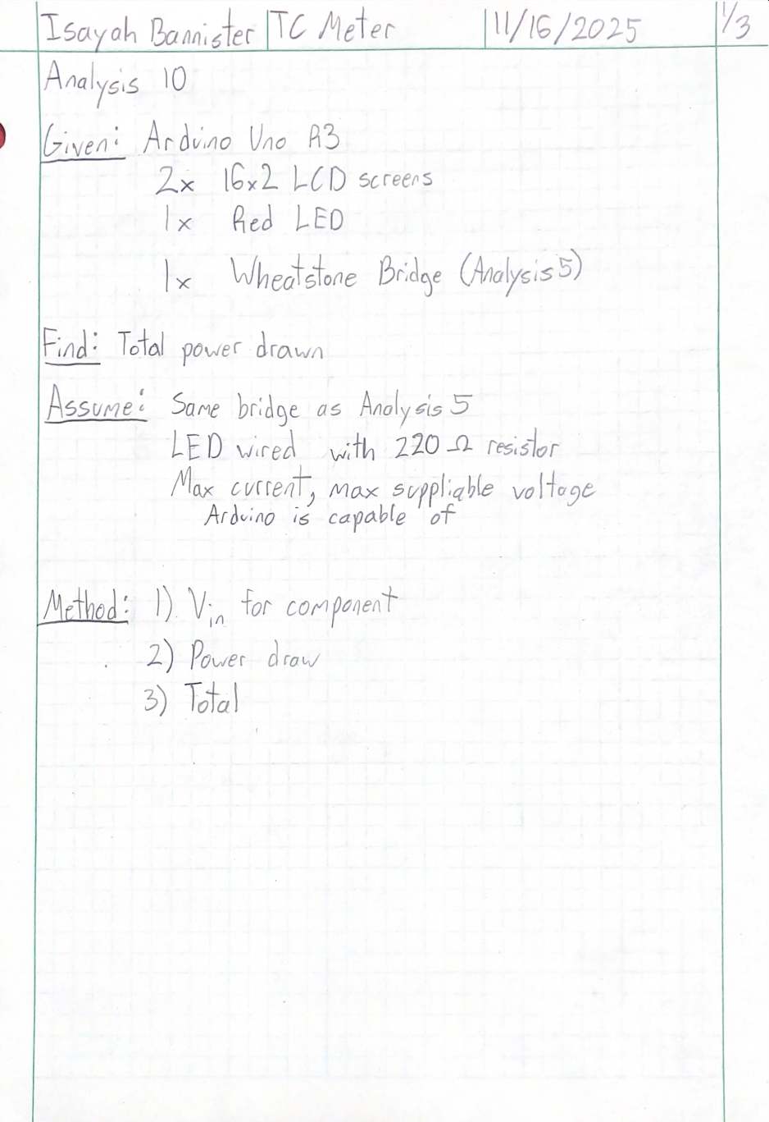
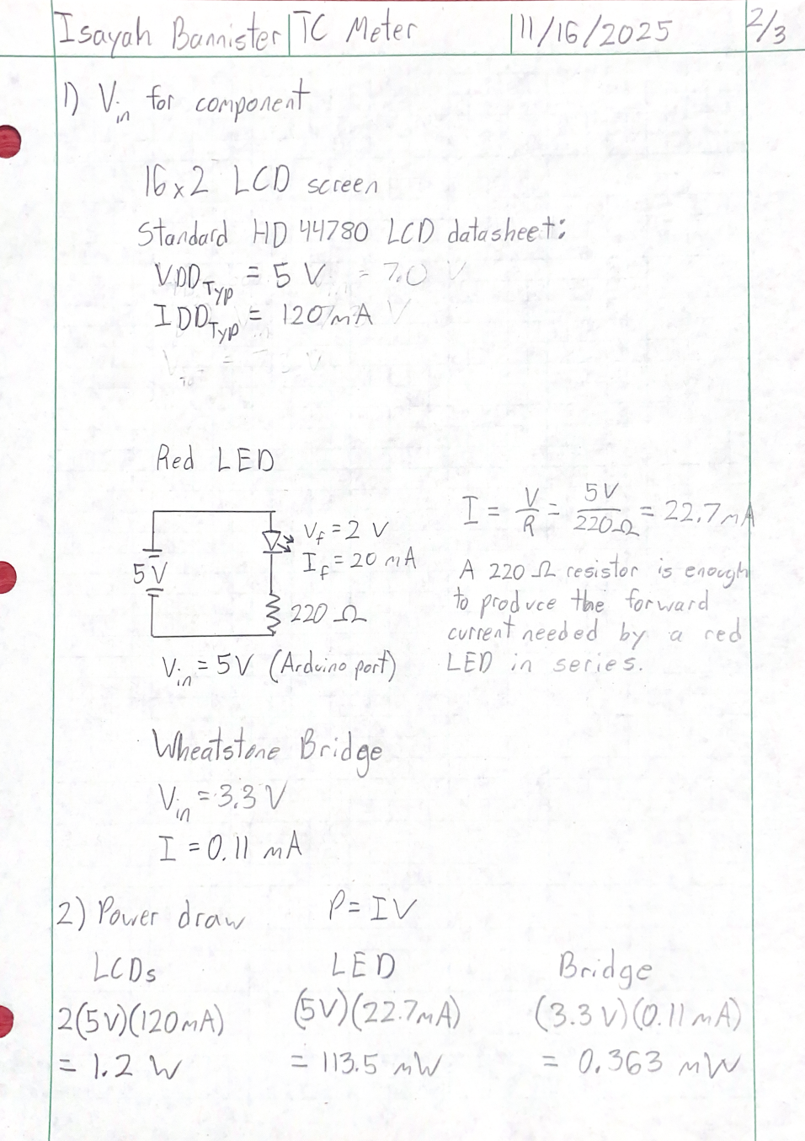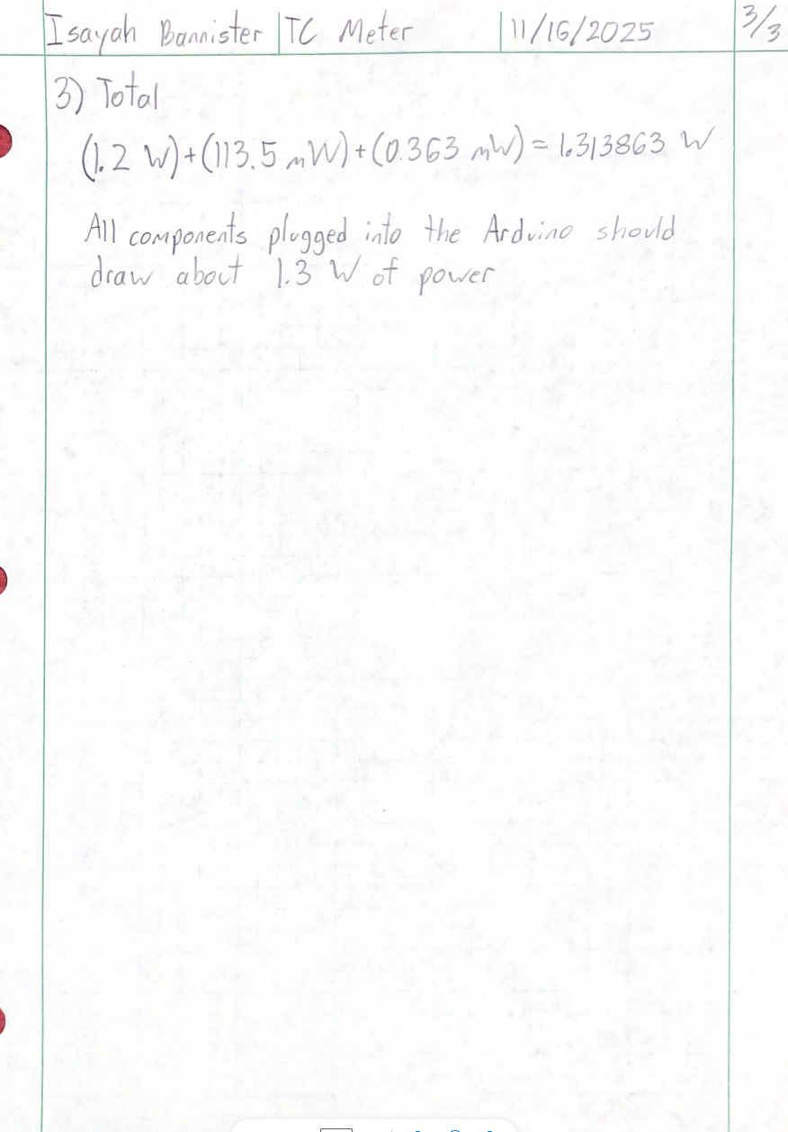

APPENDIX B - Drawings

Appendix B01 – Drawing Tree
Table B0101. IBB-10-001 Drawing Tree

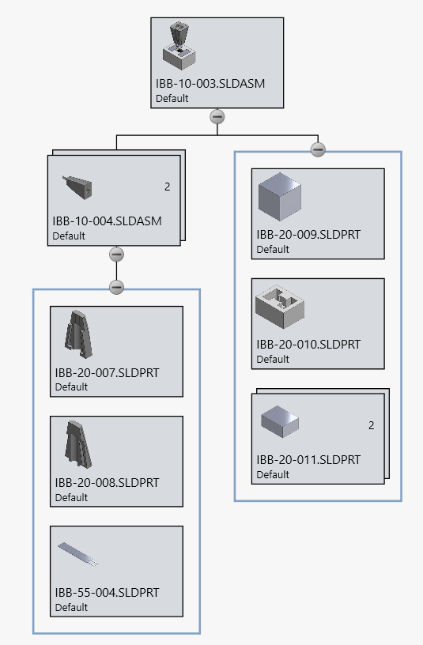
Table B0102. IBB-10-003 Drawing Tree
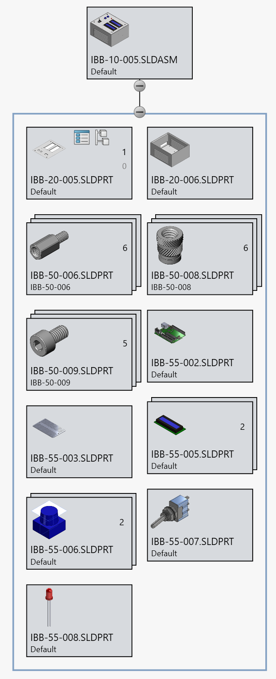
Table B0103. IBB-10-005 Drawing Tree

Appendix B02 – Drawing Index
Table B02. Drawing Index
Drawing Assignment Num. | Drawing #(s) | Date submitted
saveUpload: DWG 1 | IBB-20-001 | 10/21/2025
Upload: DWG 2 | IBB-20-002 | 10/22/2025
Upload: DWG 3 | IBB-20-003 | 10/27/2025
Upload: DWG 4 | IBB-20-004 | 10/29/2025
Upload: DWG 5 | IBB-20-005 | 11/04/2025
Upload: DWG 6 | IBB-20-006 | 11/04/2025
Upload: DWG 7 | IBB-20-007 | 11/12/2025
Upload: DWG 8 | IBB-20-008 | 11/12/2025
Upload: DWG 9, 10, & ASSY | IBB-10-001, IBB-10-002,  IBB-55-001, IBB-55-002 | 11/19/2025
Upload: Assy DWG | IBB-10-003, IBB-10-004 | 12/4/2025
Upload Proposal: Assy/Part List | IBB-10-005, IBB-50-006, IBB-50-008, IBB-50-009, IBB-55-005, IBB-55-006, IBB-55-007, IBB-55-008 | 1/9/2026

Appendix B03 – IBB-10-001 – Liquid Probe Mounting Assembly

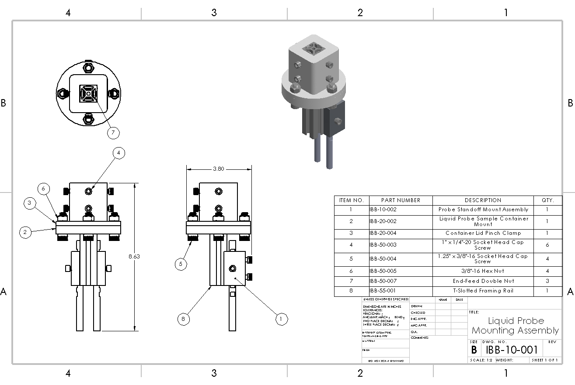

Appendix B04 – IBB-10-002 – Probe Standoff Mount Assembly

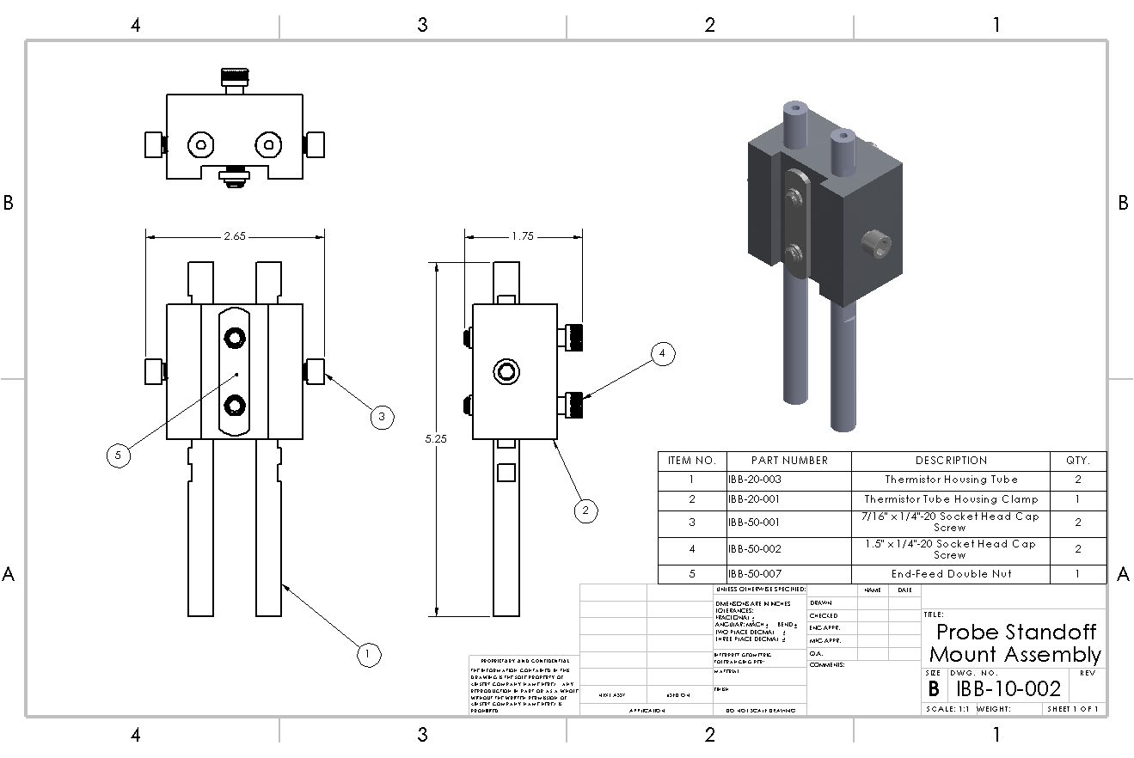

Appendix B05 – IBB-10-003 – Solid Sample Measurement Stand Assembly

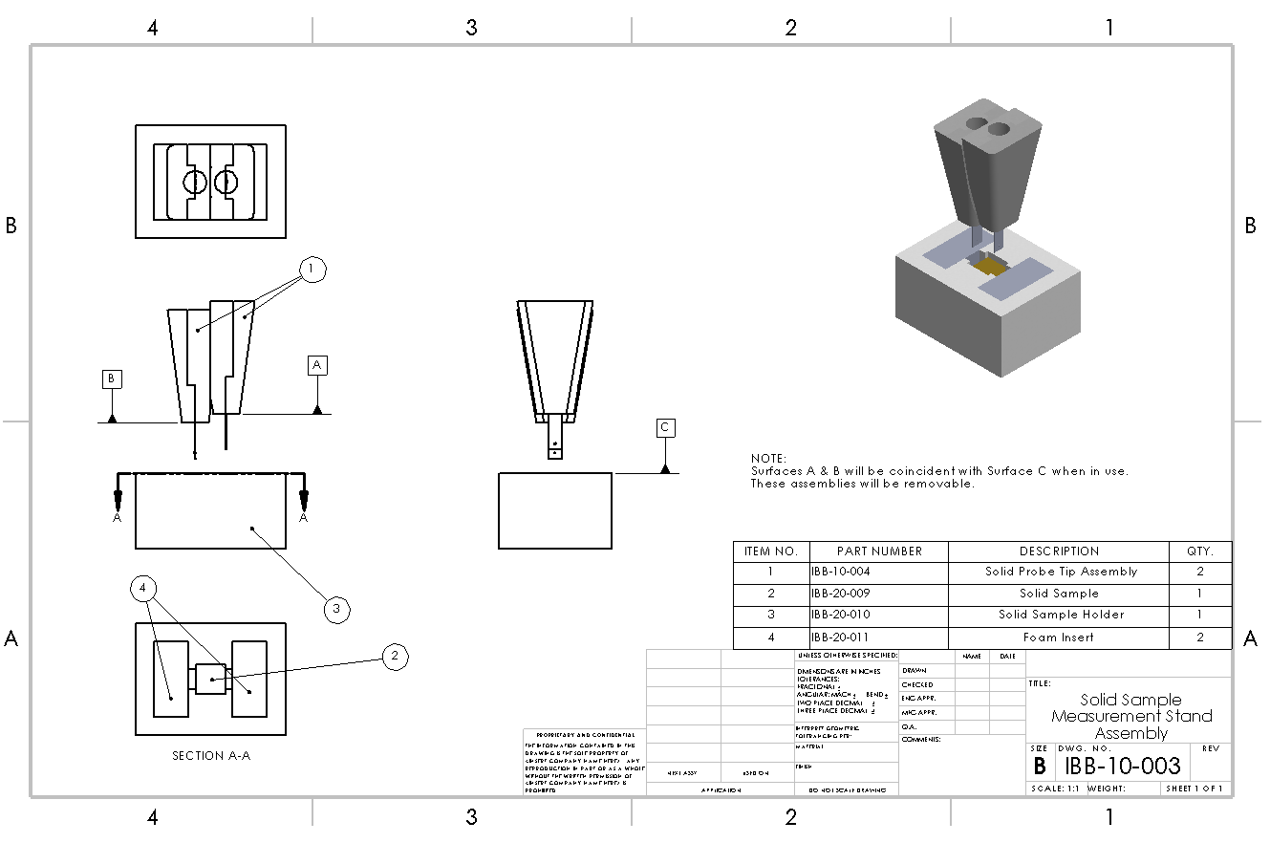

Appendix B06 – IBB-10-004 – Probe Standoff Mount Assembly

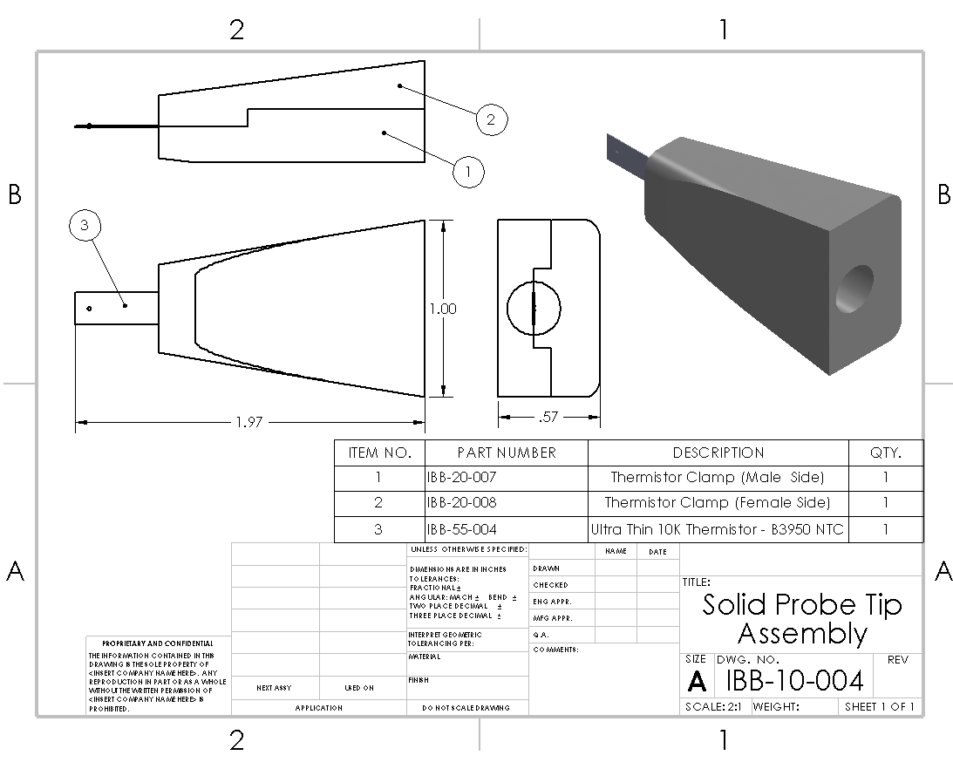

Appendix B07 – IBB-10-005 – Electronic Computing Assembly

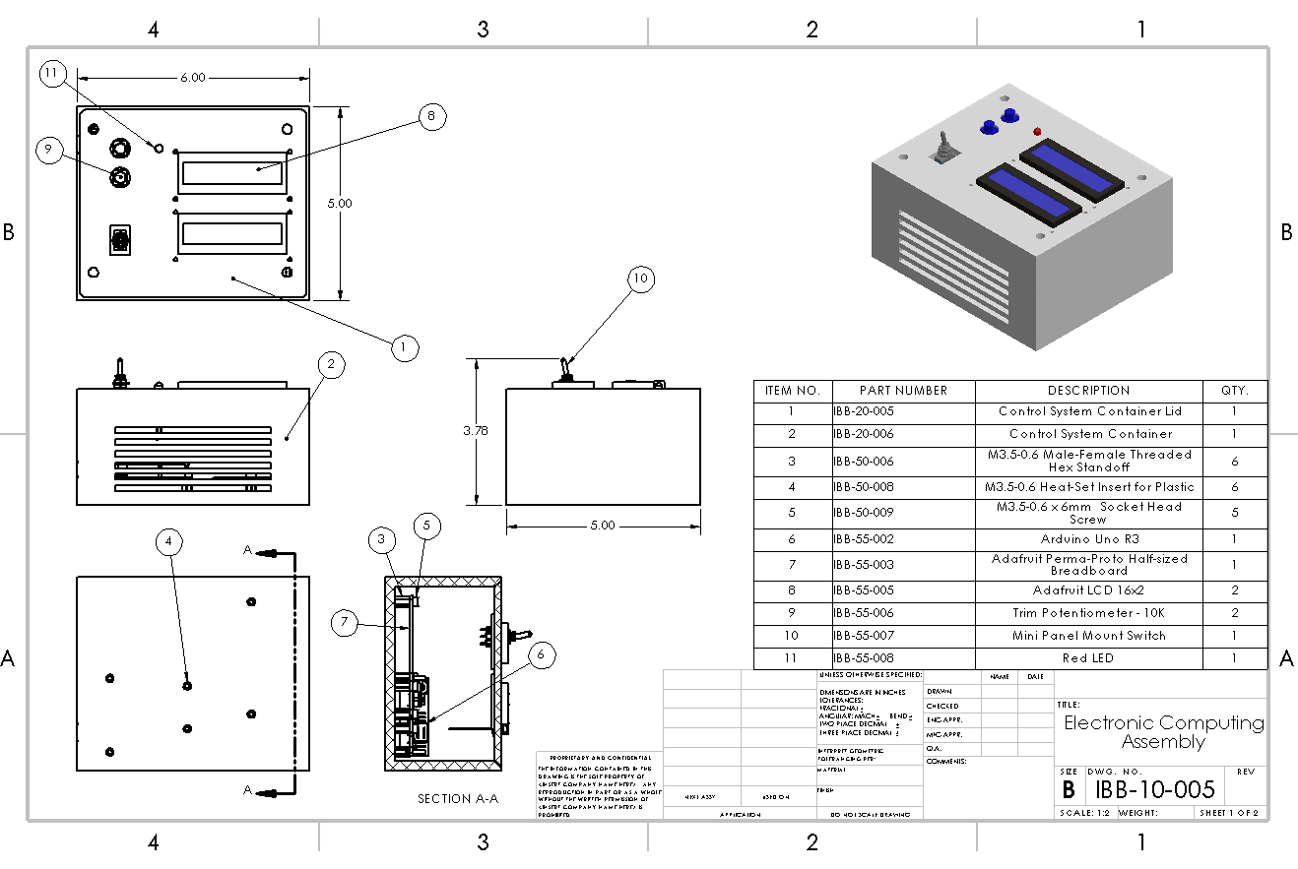

Appendix B08 – IBB-20-001 – Thermistor Tube Clamp

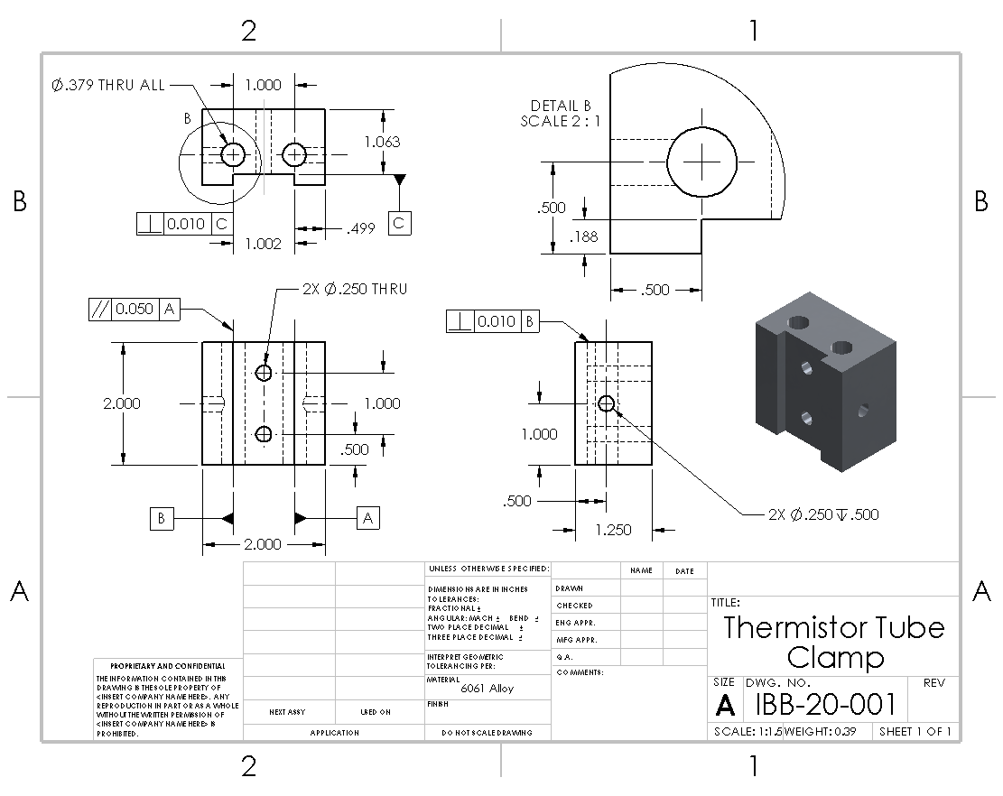

Appendix B09 – IBB-20-002 – Liquid Probe Sample Container Mount

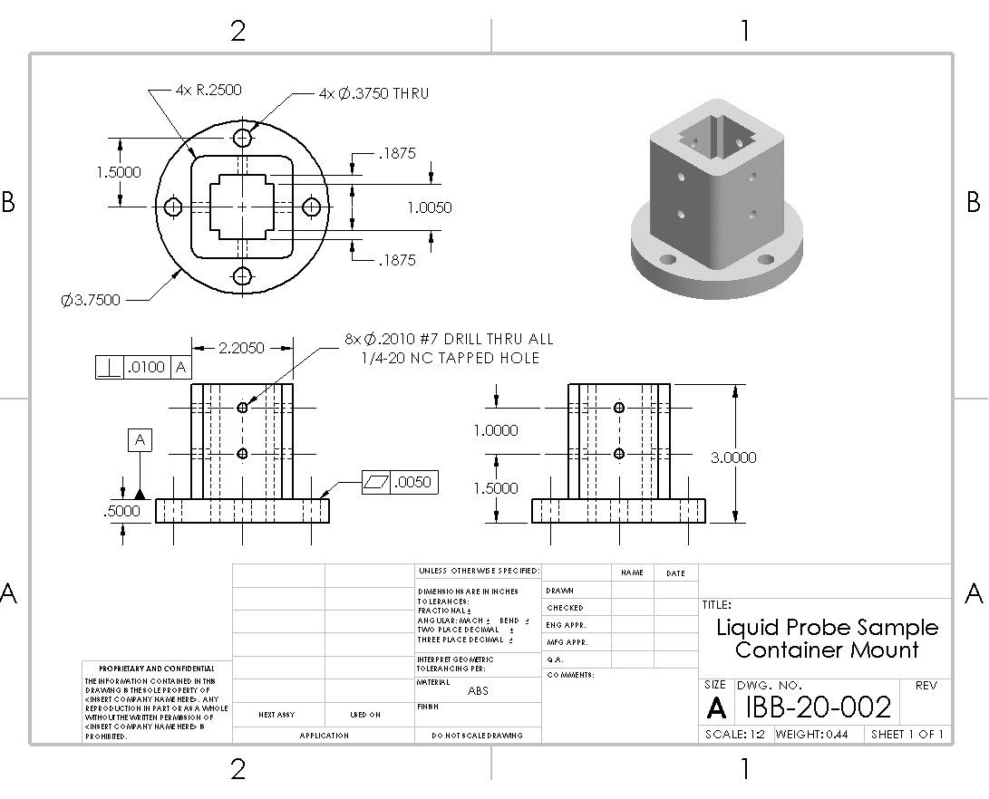

Appendix B10 – IBB-20-003 – Thermistor Housing Tube

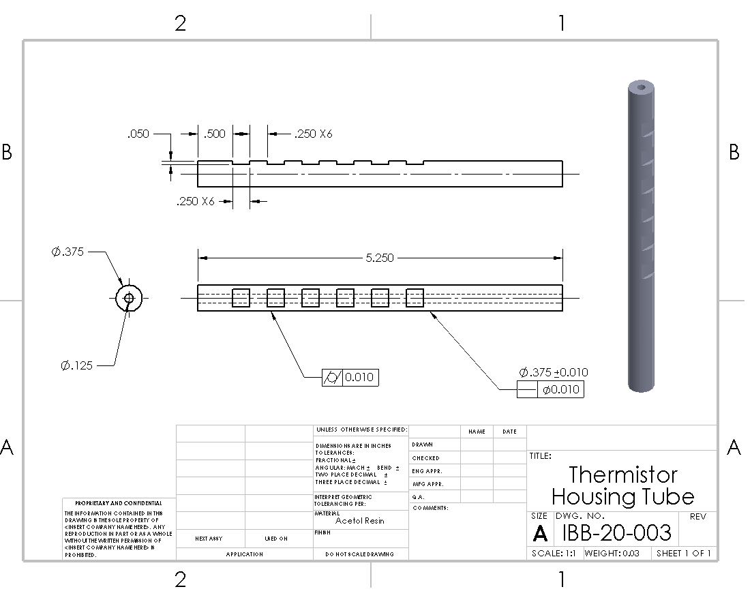

Appendix B11 – IBB-20-004 – Container Lid Pinch Clamp

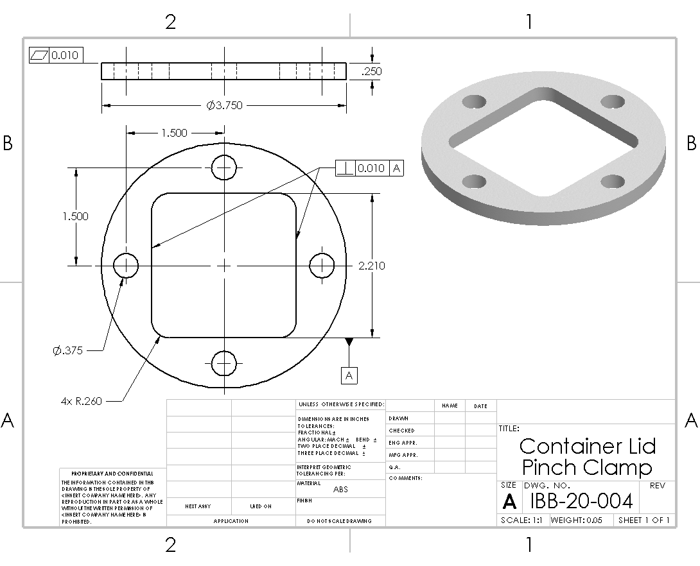

Appendix B12 – IBB-20-005 – Control System Container Lid

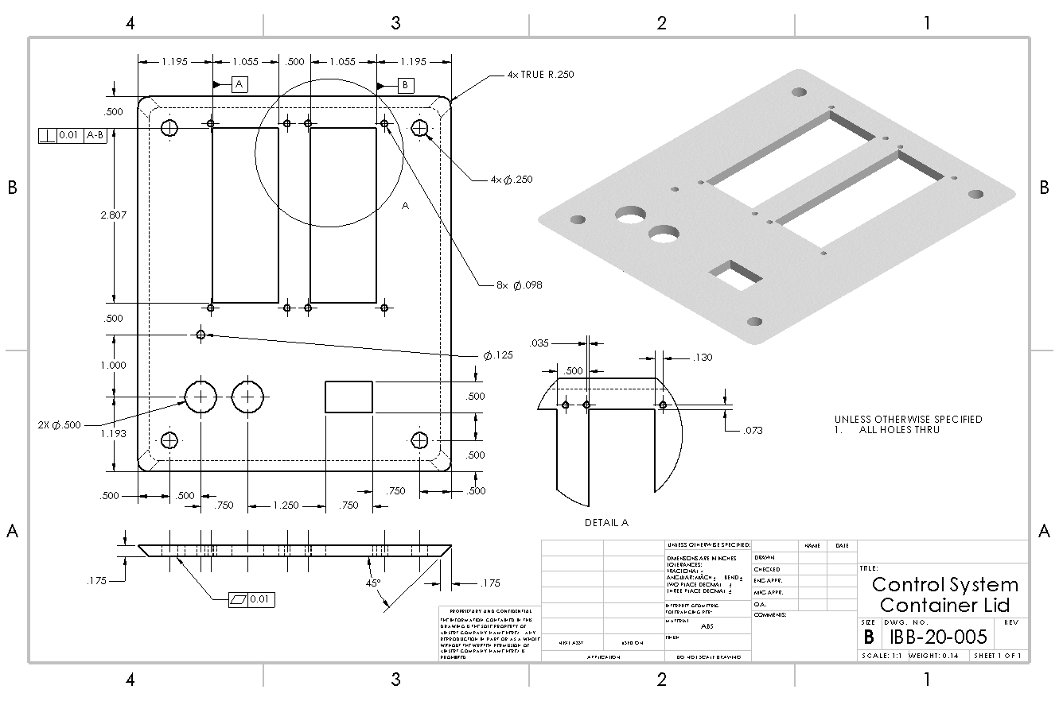

Appendix B13 – IBB-20-006 – Control System Container

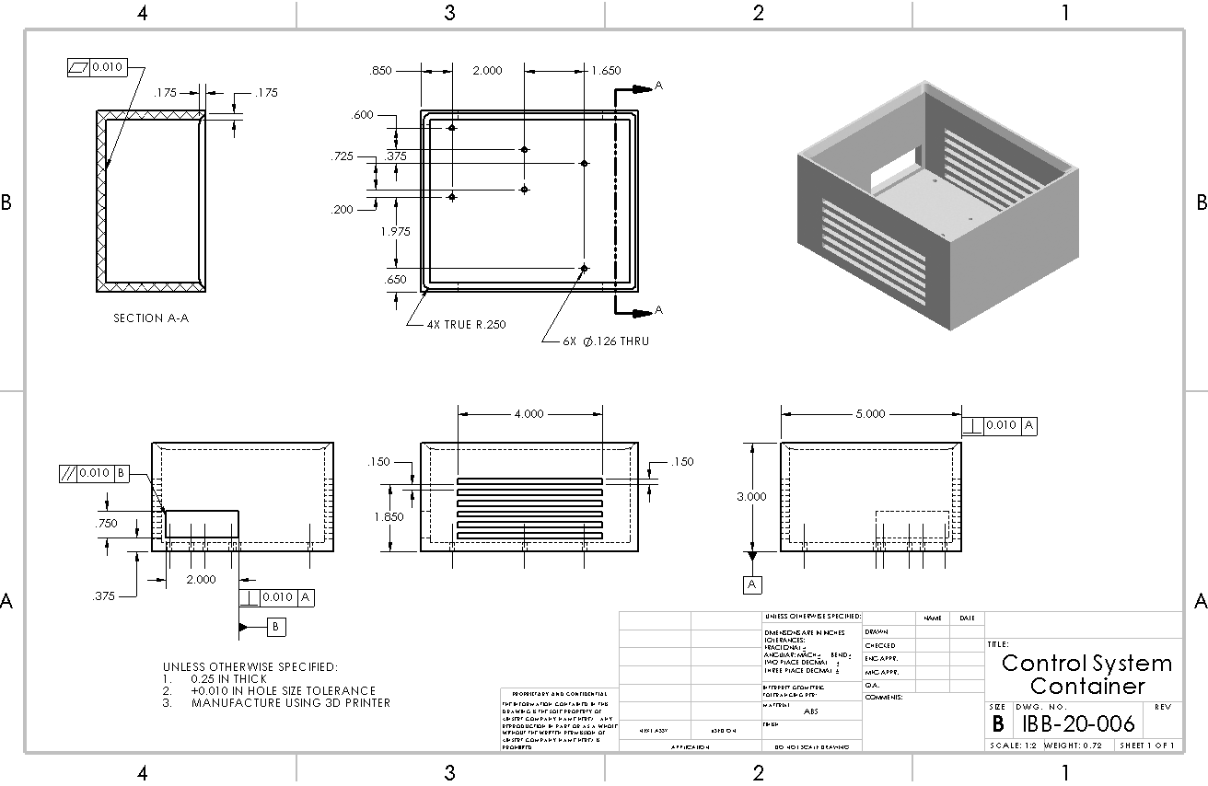

Appendix B14 – IBB-20-007 – Thermistor Clamp (Male Side)

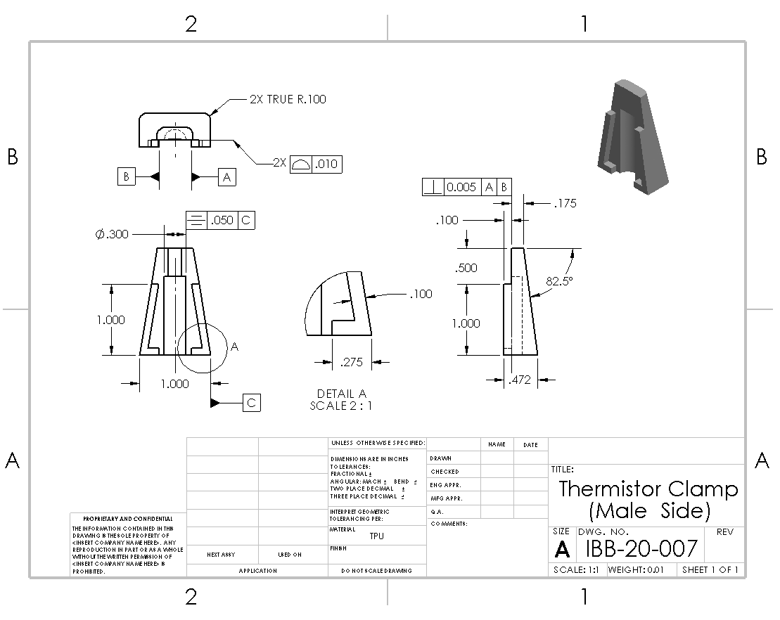

Appendix B15 – IBB-20-008 – Thermistor Clamp (Female Side)

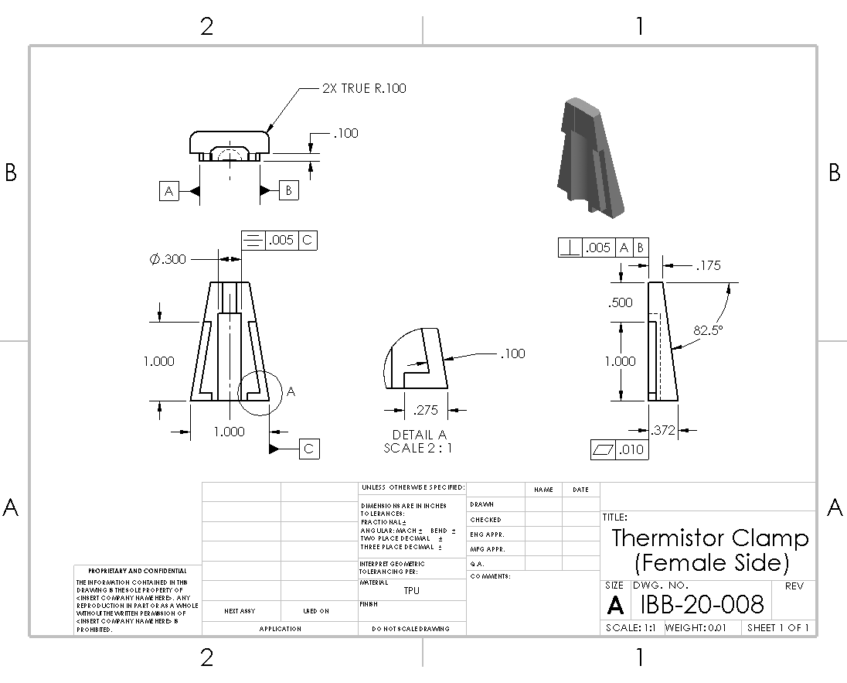

Appendix B16 – IBB-20-009 – Solid Sample

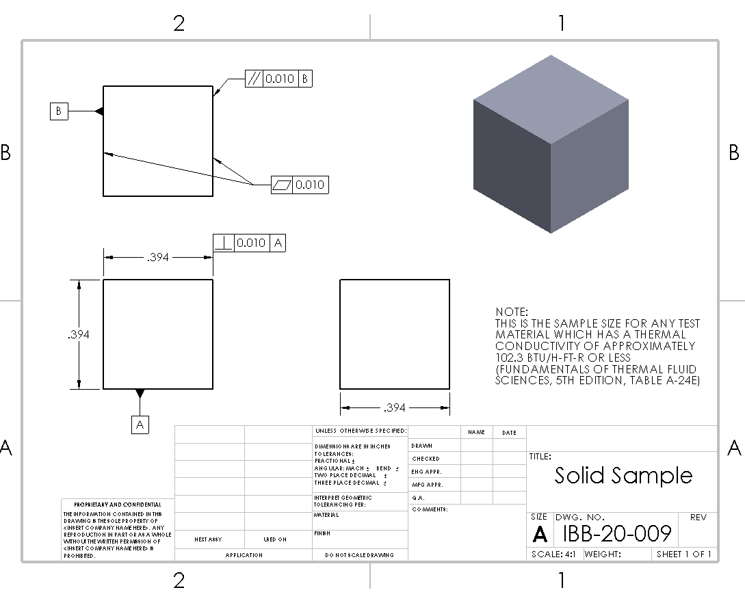

Appendix B17 – IBB-20-010 – Solid Sample Holder

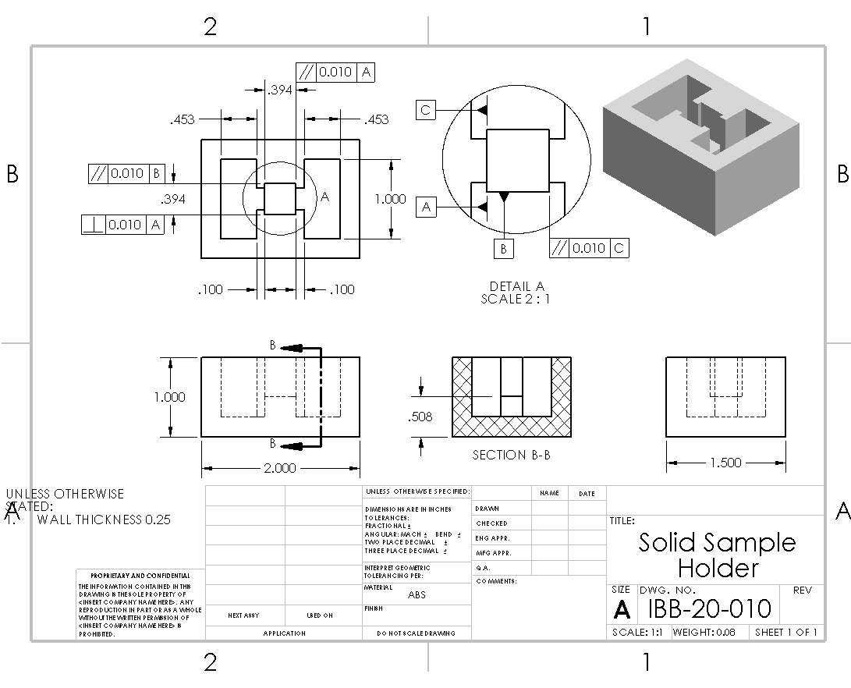

Appendix B18 – IBB-20-010 – Foam Insert
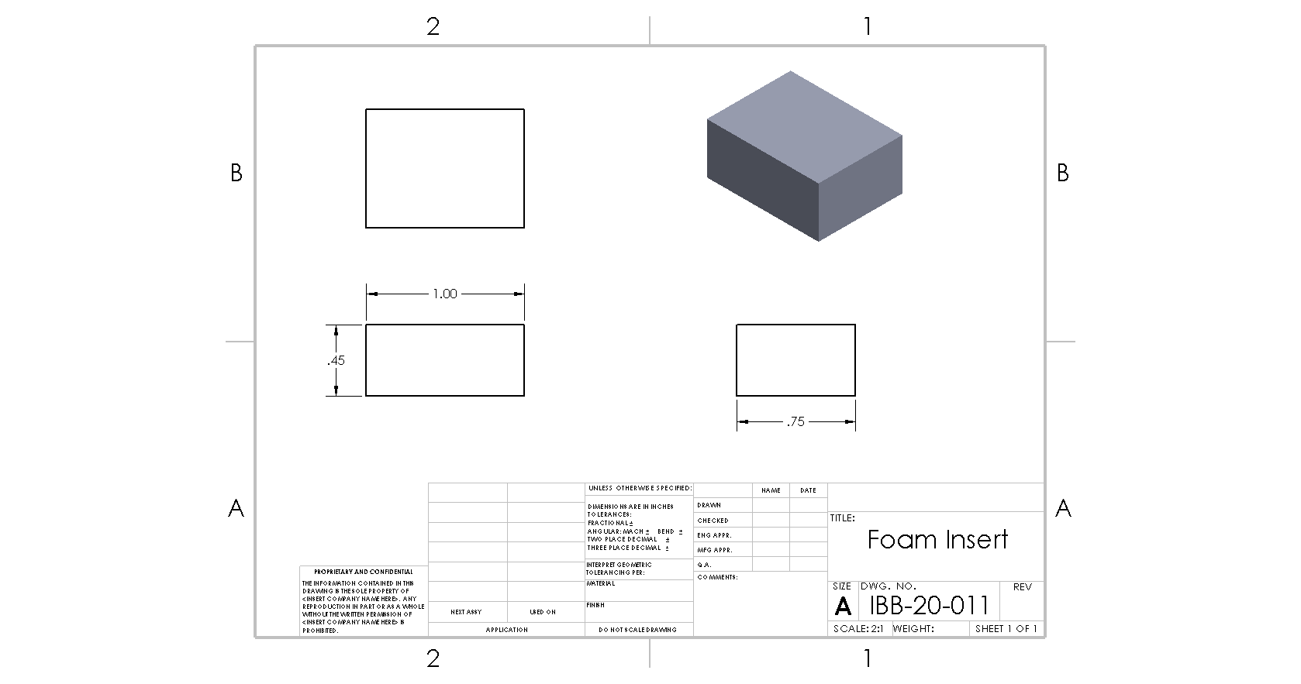

Appendix B19 – IBB-20-012 – Jar Lid

Appendix B20 – IBB-20-013 – Electronics Schematic
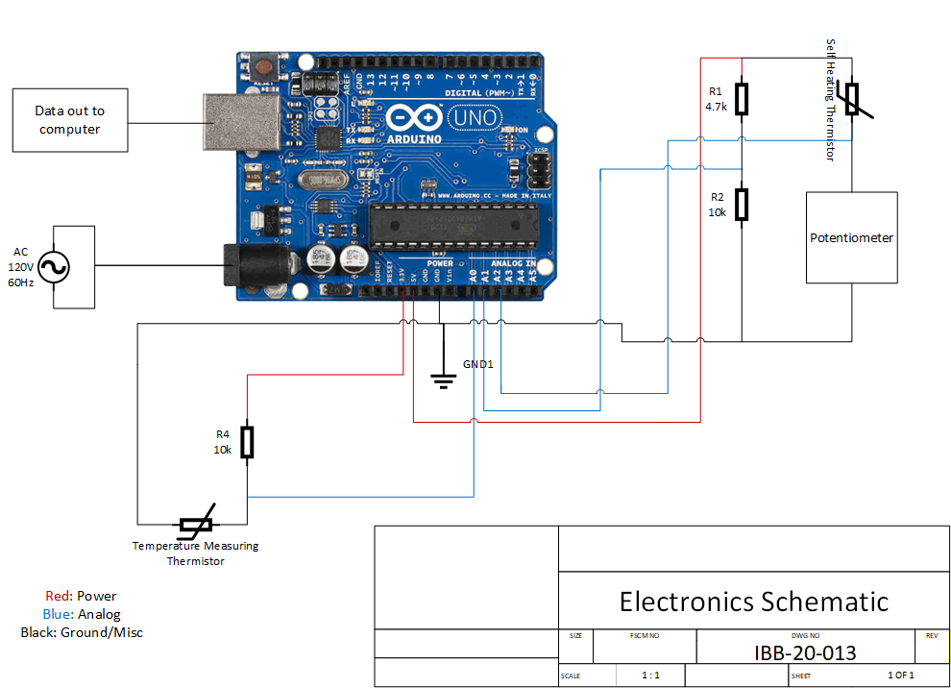

Appendix B21 – IBB-55-001 – T-Slotted Framing Rail

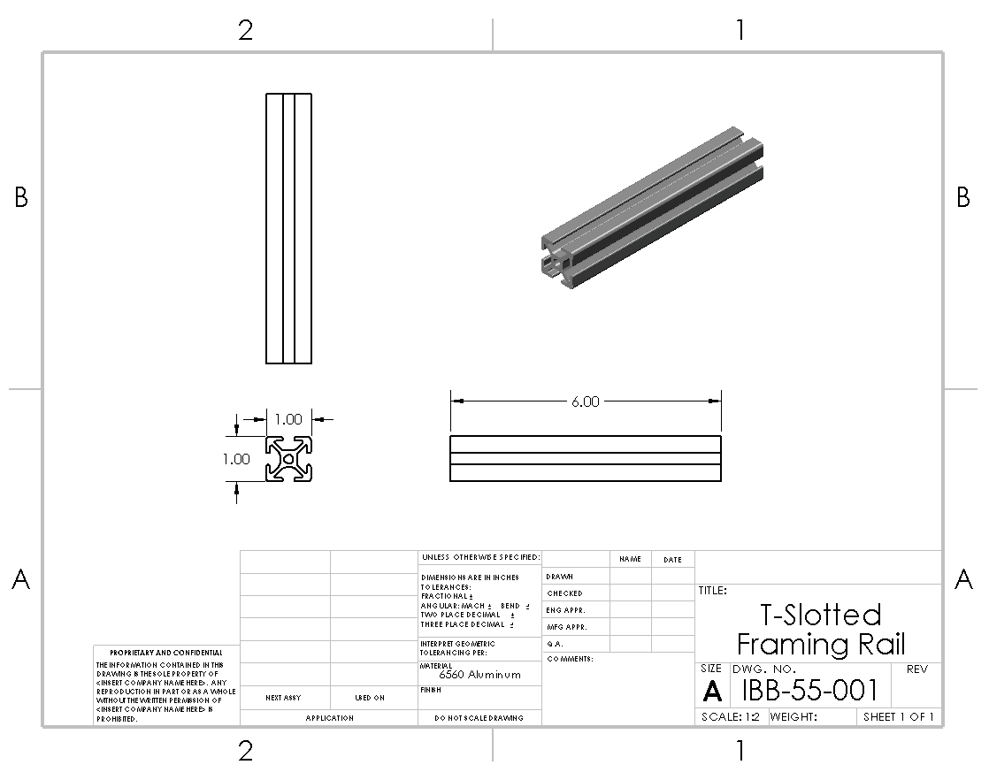

Appendix B22 – IBB-55-002 – Arduino Uno R3

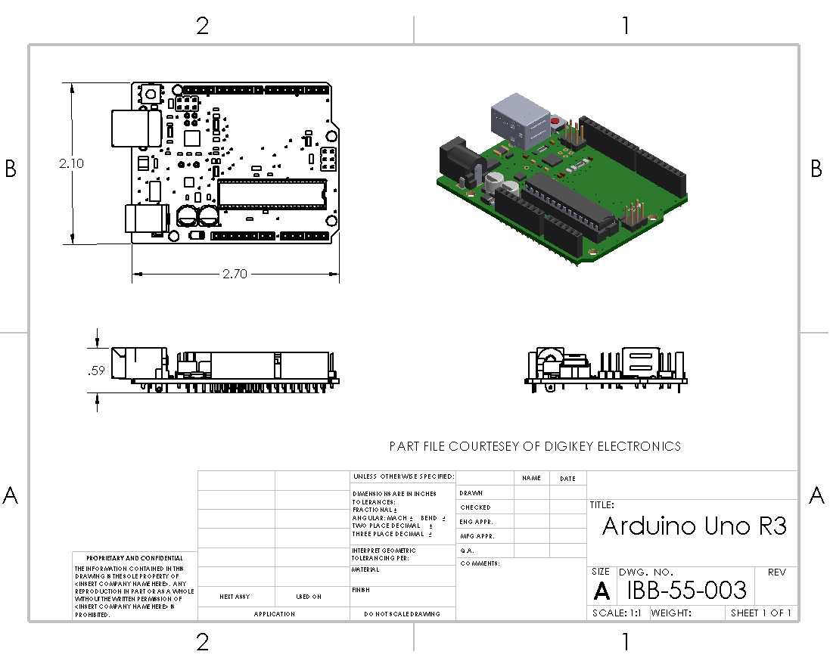

Appendix B23 – IBB-55-003 – Adafruit Perma-Proto Half-sized Breadboard PCB

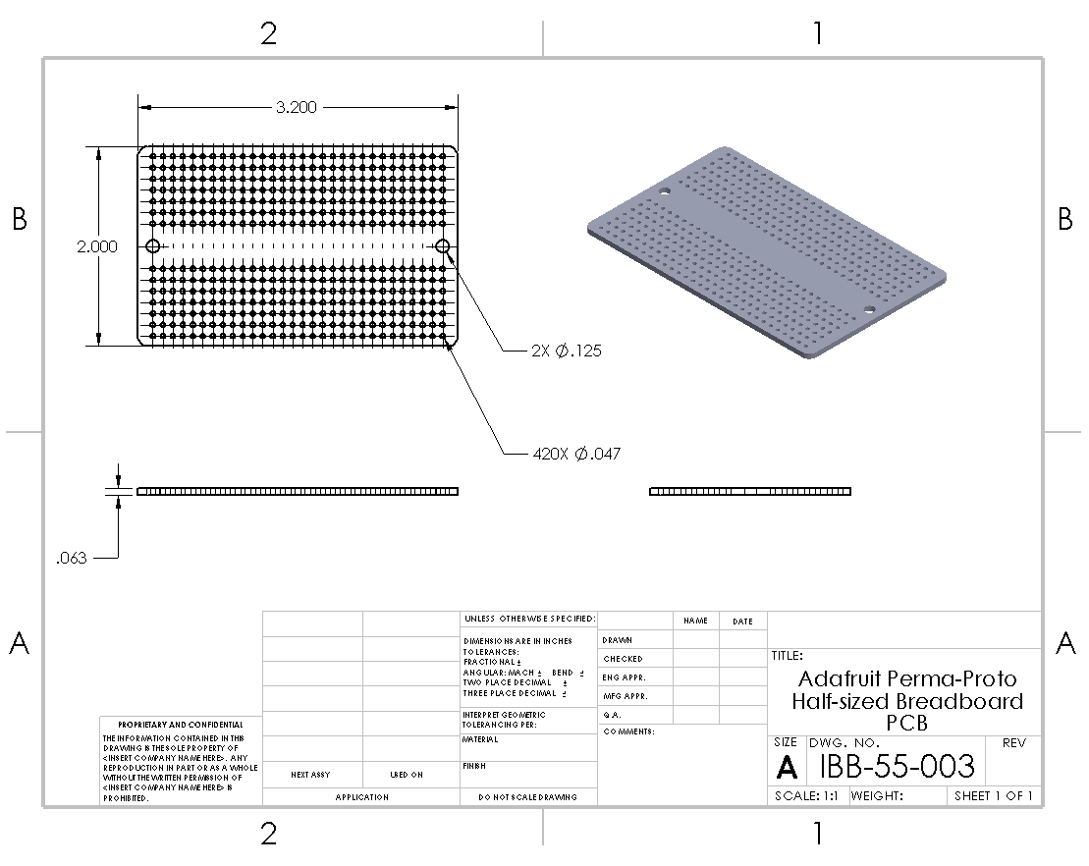

Appendix B24 – IBB-55-004 – Ultra Thin 10K Thermistor – B3950 NTC

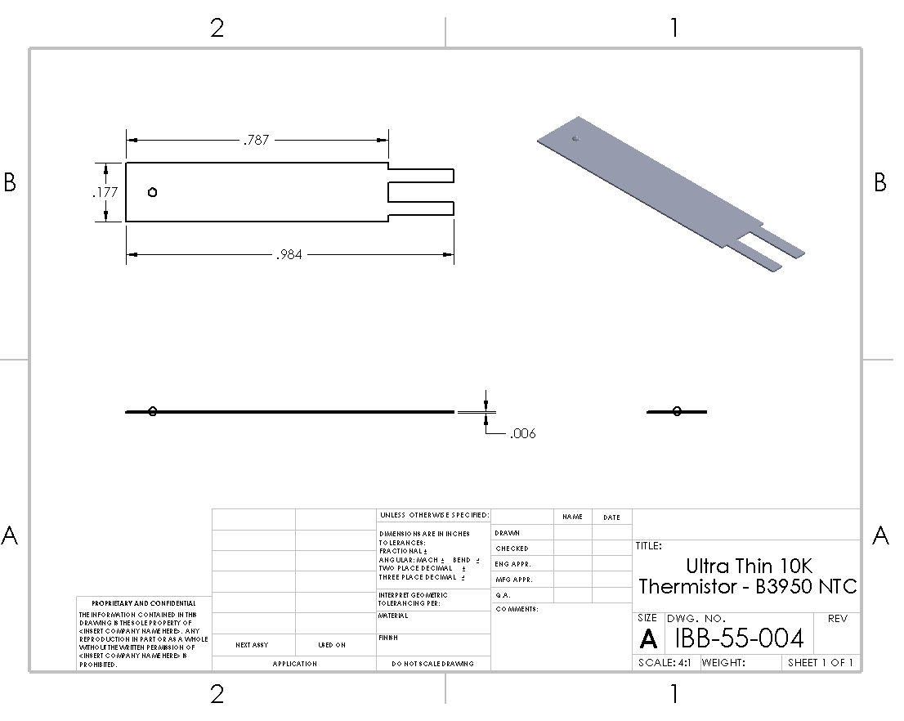

Appendix B25 – IBB-55-005 – Adafruit LCD 16x2

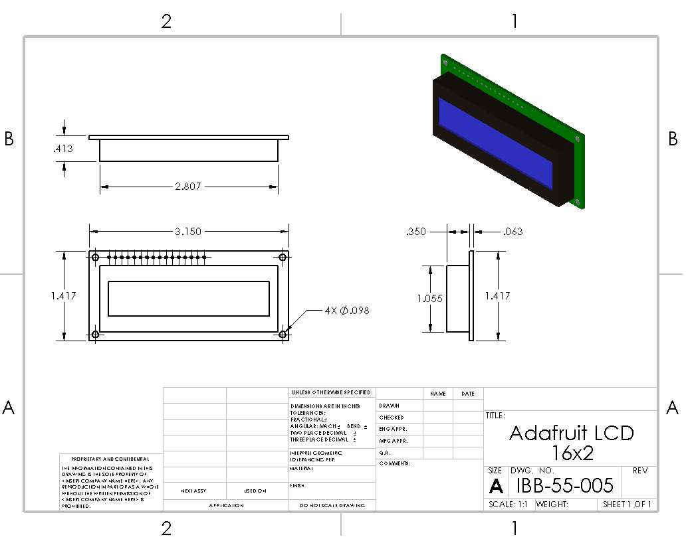

Appendix B26 – IBB-55-006 – Trim Potentiometer – 10K

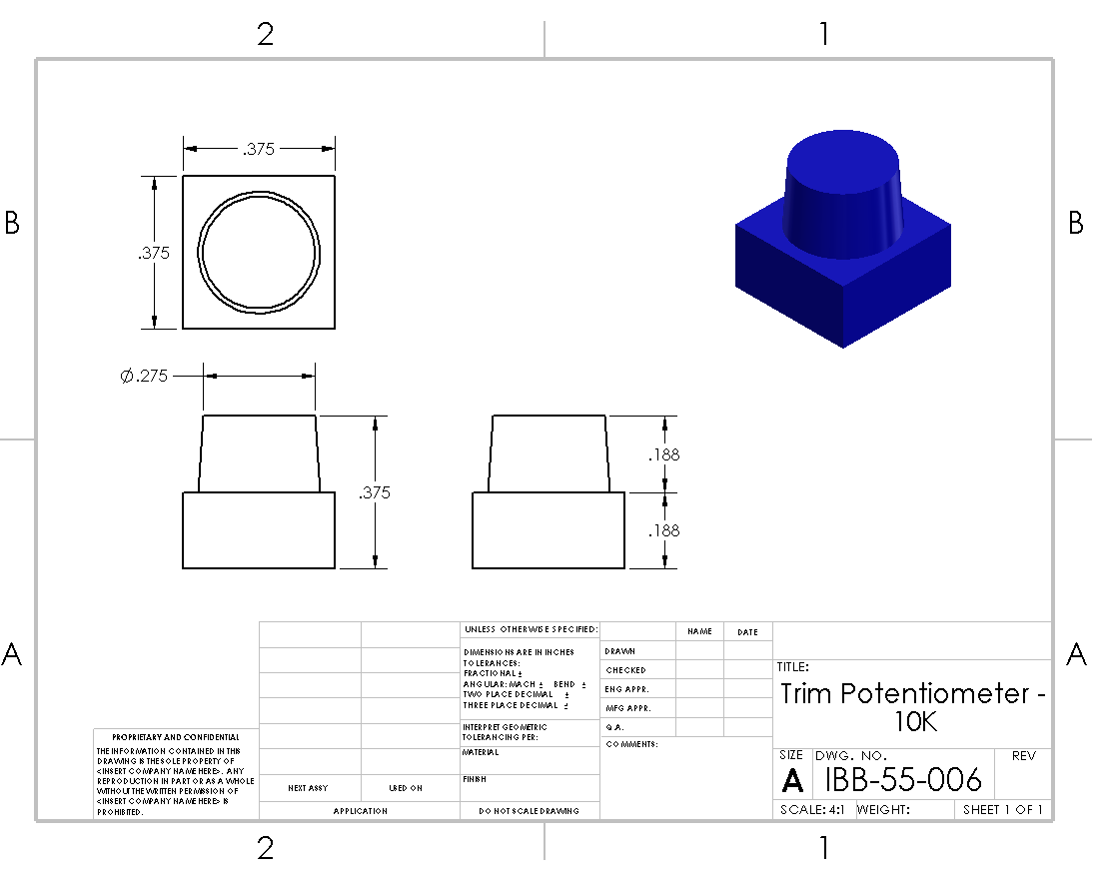

Appendix B27 – IBB-55-007 – Toggle Switch

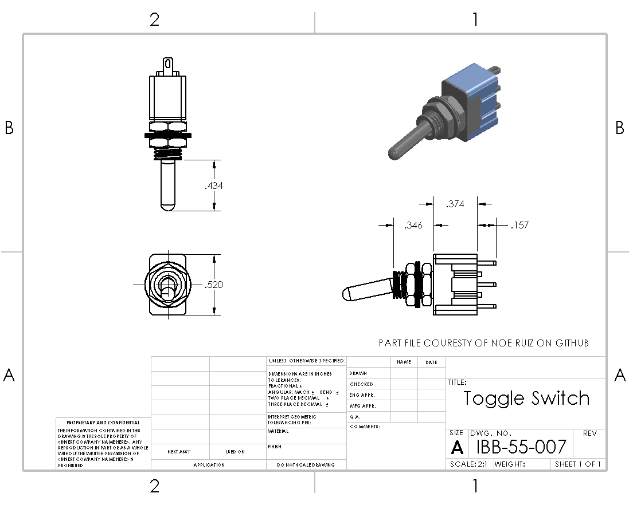

Appendix B28 – IBB-55-008 – Red LED

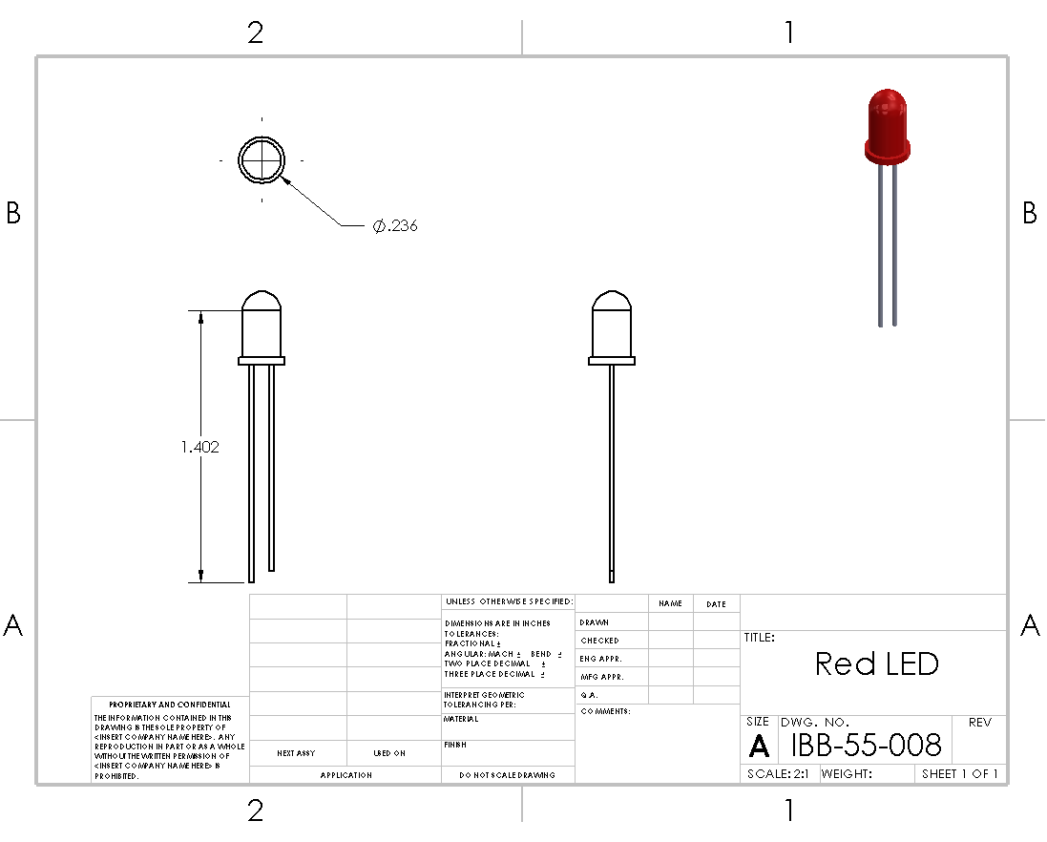

Appendix B29 – IBB-55-009 – Ball Wide Mouth Leakproof Storage Lid

APPENDIX C – Parts List and Costs
Table C1. Parts List
Part Number | Qty | Part Description | Source | Cost | Disposition
50-001 | 2 | M3 – 12mm socket head cap screw | Surplus left behind by previous seniors | N/A | Purchase by 01/15/26  In possession 01/15/26
50-002 | 2 | M3 – 40mm socket head cap screw | Surplus left behind by previous seniors | N/A | Purchase by 01/15/26  In possession 01/15/26
50-003 | 6 | M3 – 25mm socket head cap screw | Surplus left behind by previous seniors | N/A | Purchase by 01/15/26  In possession 01/15/26
50-004 | 4 | M3 – 35mm socket head cap screw | Surplus left behind by previous seniors | N/A | Purchase by 01/15/26  In possession 01/15/26
50-005 | 4 | M3 nut | Surplus left behind by previous seniors | N/A | Purchase by 01/15/26  In possession 01/15/26
50-006 | 6 | M3 Hex Standoff | McMaster-Carr | $0.81 | Purchase by 01/15/26  Purchased 01/13/26  Delivered 01/16/26
50-007 | 4 | End-Feed Double Nut | McMaster-Carr | $7.83/pkg  (25/pkg) | Purchase by 01/15/26  Purchased 01/13/26  Delivered 01/16/26
50-008 | 1 | Heat-Set Thread Insert | McMaster-Carr | $7.27/pkg  (25/pkg) | Purchase by 01/15/26  Purchased 01/13/26  Delivered 01/16/26
50-009 | 6 | M3 – 6mm socket head cap screw | Surplus left behind by previous seniors | N/A | Purchase by 01/15/26  In possession 01/15/26
55-001 | 1 ft | 6”x20mmx20mm T-Slotted Framing Rail | McMaster-Carr | $8.67 | Purchase by 01/15/26  Purchased 01/13/26  Delivered 01/16/26
55-002 | 1 | Arduino Uno R3 | Arduino Store | $27.60 | Ordered 11/11/25  Paid $17.94 due to Black Friday sale  Delivered 11/17/25
55-003 | 1 | Perma-Proto Breadboard | Adafruit.com | $4.50 | Ordered 11/23/25  Delivered 12/02/26
55-004 | 2 | NTC Thermistor (Thin) | Adafruit.com | $0.95 | Ordered 11/23/25  Delivered 12/02/26
55-005 | 2 | 12x2 LCD Display | Adafruit.com | $10.95 | Ordered 11/23/25  Delivered 12/02/26
55-006 | 2 | Trim Potentiometer | Adafruit.com (come with purchase of LCD Displays) | N/A | Ordered 11/23/25  Delivered 12/02/26
55-007 | 1 | Toggle Switch | Adafruit.com | $3.95 | Purchase by 01/15/26  Ordered 01/15/26  Delivered 01/21/26
55-008 | 1 | Red 5mm LED | Adafruit.com | $4.00  (25/pkg) | Purchase by 01/15/26  Ordered 01/15/26  Delivered 01/21/26
55-009 | 1 | Ball Wide Mouth Leakproof Storage Lid | Fred Meyer | $9.26  (6/pkg) | Purchased 01/12/26
55-010 | 1 | Power Supply | Adafruit.com | $24.95 | Ordered 11/23/25  Delivered 12/02/26
55-011 | 1 | USB-B to USB-A Cable | Arduino Store | $6.50 | Ordered 11/11/25  Delivered 11/17/25
55-012 | 2 | NTC Thermistor (Point) | Adafruit.com | $4.00 | Ordered 11/23/25  Delivered 12/02/26
55-013 | 2 | 10 kΩ resistor (0.1%) | Adafruit.com (come with purchase of thermistors) | N/A | Ordered 11/23/25  Delivered 12/02/26
55-014 | 1 | 4.7 kΩ resistor (5%) | Adafruit.com | $0.75  (25/pkg) | Purchase by 01/15/26  Ordered 01/15/26  Delivered 01/21/26
55-015 | 1 | 10 kΩ resistor (5%) | Adafruit.com | $0.75  (25/pkg) | Purchase by 01/15/26  Ordered 01/15/26  Delivered 01/21/26
55-016 | 1 | 10 kΩ potentiometer | Adafruit.com | $0.95 | Purchase by 01/15/26  Ordered 01/15/26  Delivered 01/21/26
55-017 | 2 | Wire (25 ft – 22 AWG) | Adafruit.com | $2.95/spool | Purchase by 01/15/26  Ordered 01/15/26  Delivered 01/21/26
55-018 | 1 | 1 Qt Wide Mouth Glass Jar | Ellensburg Goodwill | $1.00 | Purchase by 01/15/26  Purchased 01/12/26
55-019 | 1 | Potentiometer Knob | Adafruit.com | $0.50 | Purchase by 01/15/26  Ordered 01/15/26  Delivered 01/21/26
Taxes |  |  |  | Assume 10% of running total to start  11/11/25 order: $2.87  11/23/25 order: $4.03  1/12/26 order: $3.69  1/15/26 order: $5.54
Shipping |  |  |  | Assume 5% of running total, after taxes  11/11/25 order: $8.82  11/23/25 order: $8.35  1/12/26 order: $7.85  1/15/26 order: $11.80
Discount (deducted from order total) |  |  |  | 11/11/25 order: 30% off Arduino only  11/23/25 order: -$6.79 (15% off order)
Total Spent |  |  |  | As of 11/11/25: $36.13  As of 11/23/25: $86.97  As of 1/12/26: $120.03  As of 1/15/26: $190.90

APPENDIX D – Budget

Table D1. Project Budget.
Item | Qty | Description | Cost
Domain Name | 1 | 1 year ownership of www.thermal-conductivity-meter.com | $11.36
Website | 1 | 1 year of WordPress.com Personal website subscription | $52.14
Parts | All | Listed in Appendix C | $240.81
Electronic Assembly Labor | 10 hours | Labor spent on assembling the electronic systems (i.e. probe wiring, Arduino coding, breadboard arranging, etc.) | $16.66/hr
Mechanical Assembly Labor | 3 hours | Labor spent on assembling the mechanical systems (i.e. probe assembling, case assembling, etc.) | $16.66/hr
Component Manufacturing Labor | 5 hours | Labor spent on machining and manufacturing components, including time spent on slicer or CAM programs | $16.66/hr
Machine Time | 50 hours | Machine downtime or maintenance time directly caused by usage for this project | $5/hr
Total Budget (including shipping and taxes) |  |  | $854.19

APPENDIX E – Schedule

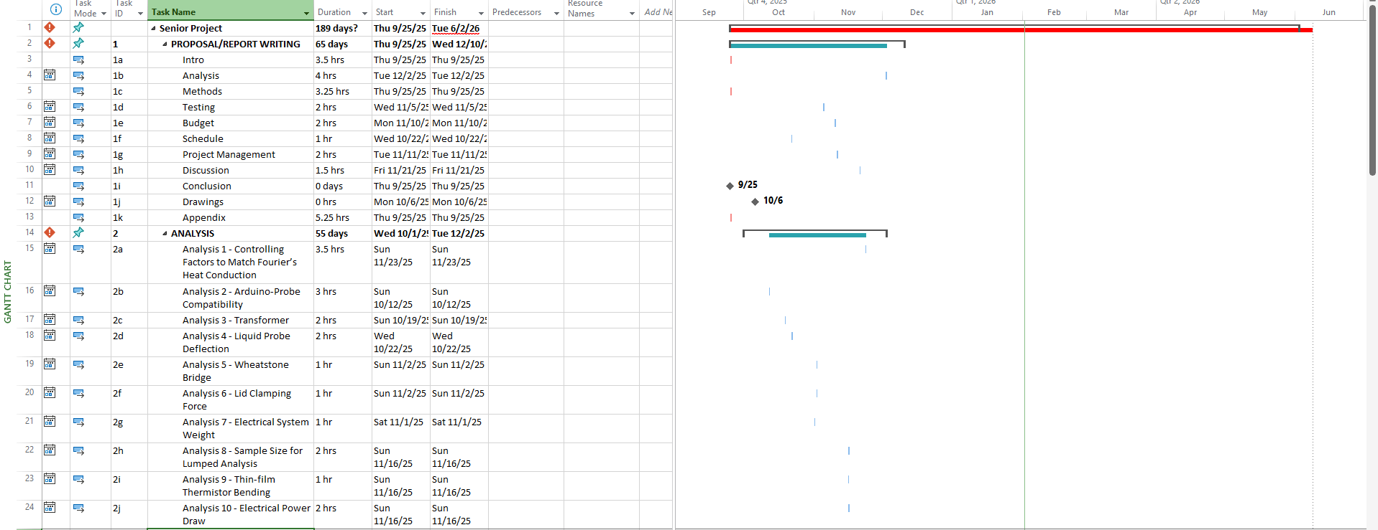
Figure E1. Project Gantt Chart, Proposal-Analysis.

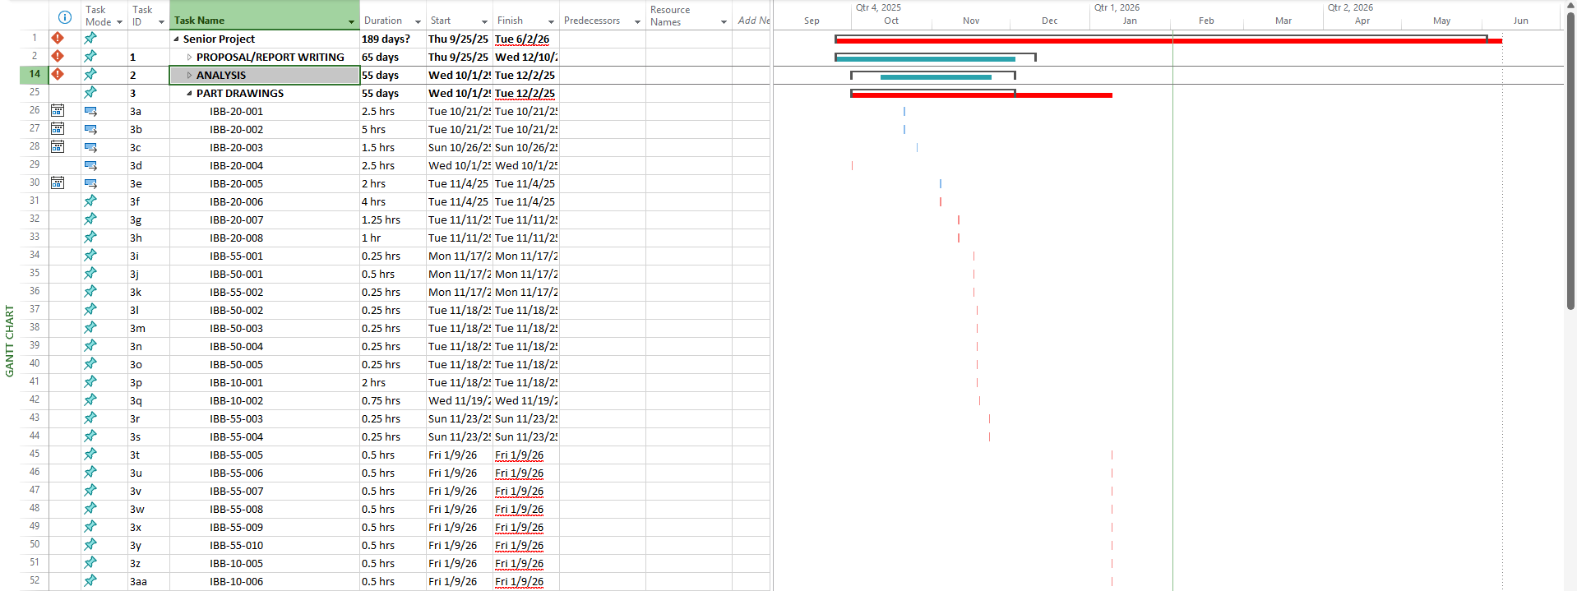
Figure E2. Project Gantt Chart, Part Drawings

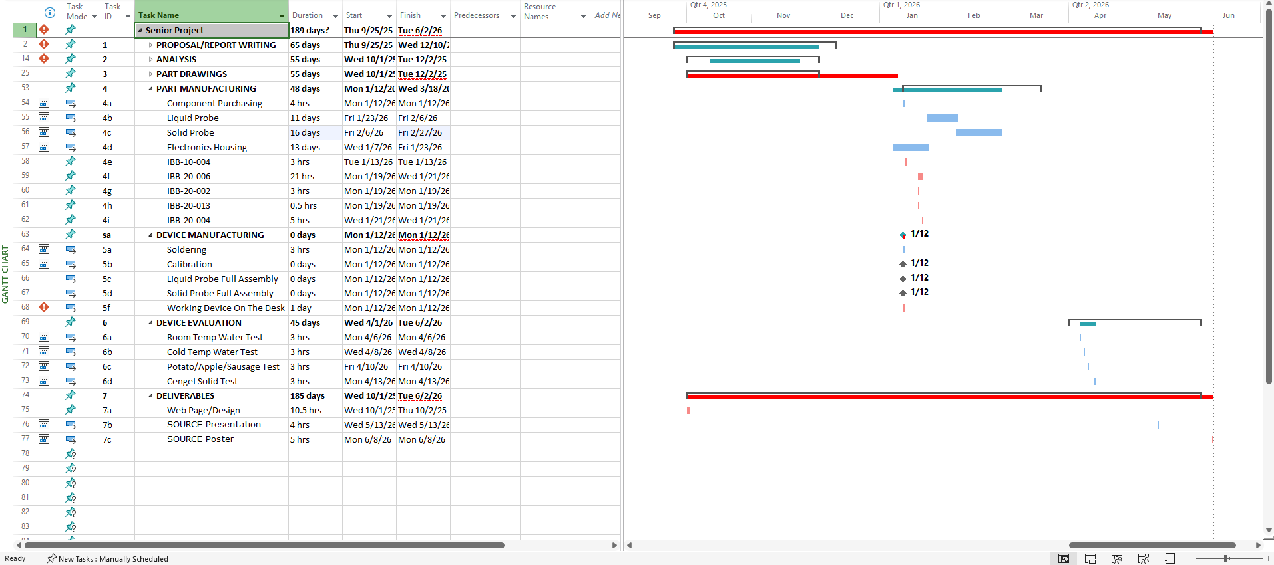
Figure E3. Project Gantt Chart, Part Manufacturing-Deliverables.

Appendix F – Expertise and Resources
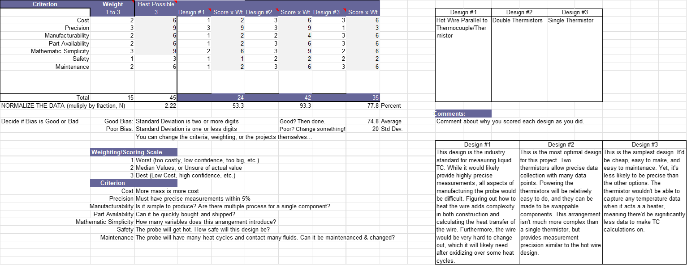
Figure F1. Thermistor Arrangement Decision Matrix
This served to narrow down the choice for heating/measuring element in the liquid probe. Ultimately, two tandem thermistors were chosen. The losing choices were a thermistor/hot wire combo and a single thermistor.

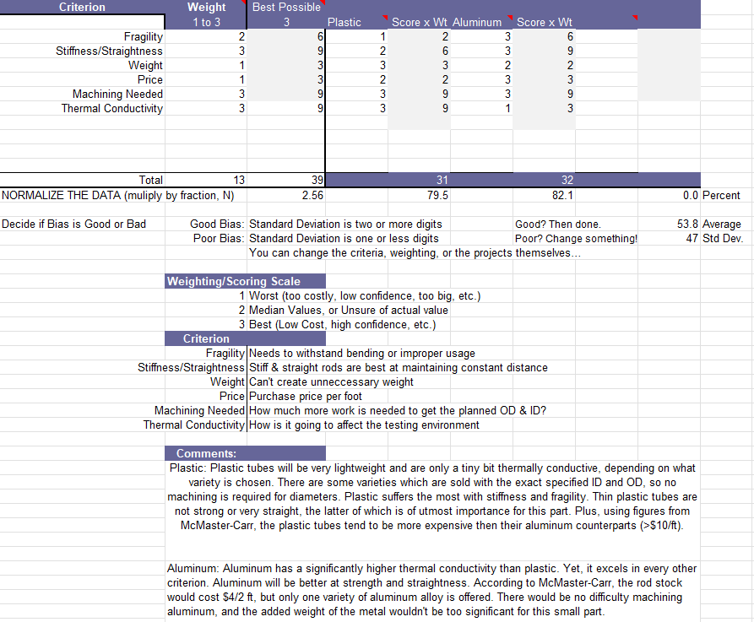
Figure F2. IBB-20-003 Material Choice Decision Matrix
IBB-20-003 will be a tube which will contact the liquid environment being measured. Since manufacturability and the affect this material would have on the environment were highly important criterion, it was decided that aluminum will be the best material choice.

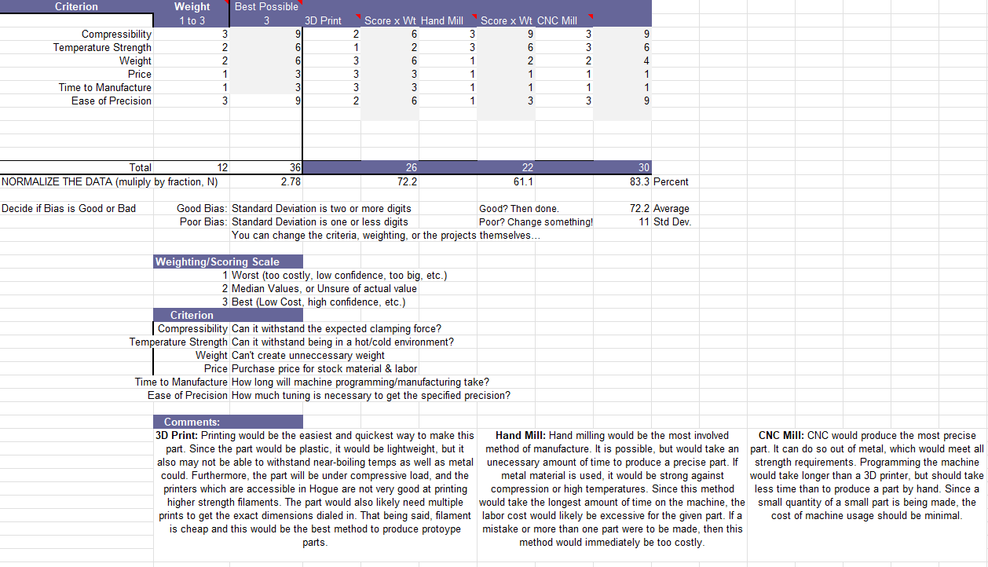
Figure F3. IBB-20-004 Manufacturing Method Decision Matrix
IBB-20-004 will be a clamping plate. Since this component will see a high amount of compression, it was decided that a manufacturing method capable of machining metal materials would be best. CNC milling produces the highest accuracy parts and can easily be reproduced, so this method was chosen.

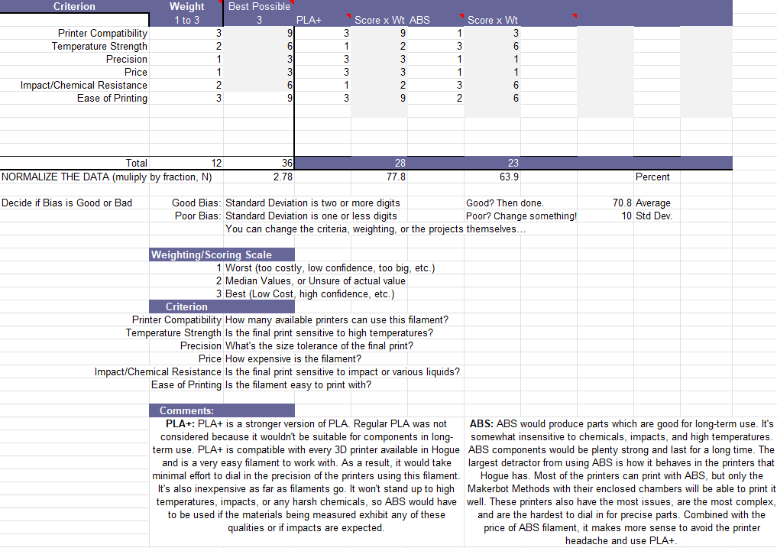
Figure F4. 3D Printer Filament Decision Matrix.
Aside from components IBB-20-007 and IBB-20-008, all components which will be 3D printed can be done so out of the same filament. This matrix found that though ABS would be a good material, it wouldn’t be worth using due to the manufacturing difficulties that come with using the filament in the 3D printers Hogue has available. PLA+ will be sufficient enough for the intent of each component and can be easily calibrated for precise parts.

APPENDIX G – Testing Report

Appendix G1 (Room Temperature Water)

Introduction

Method/Approach

Test Procedure

Deliverables

Appendix G1.1 – Procedure Checklist

Appendix G1.2 – Data Forms

Appendix G1.3 – Raw Data

Appendix G1.4 – Evaluation Sheet

Appendix G1.5 – Schedule (Testing)

Appendix G2 (Near-Freezing Water)

Introduction

Method/Approach

Test Procedure

Deliverables

Appendix G2.1 – Procedure Checklist

Appendix G2.2 – Data Forms

Appendix G2.3 – Raw Data

Appendix G2.4 – Evaluation Sheet

Appendix G2.5 – Schedule (Testing)

Appendix G3 (Appendix Solid)

Introduction

Method/Approach

Test Procedure

Deliverables

Appendix G3.1 – Procedure Checklist

Appendix G3.2 – Data Forms

Appendix G3.3 – Raw Data

Appendix G3.4 – Evaluation Sheet

Appendix G3.5 – Schedule (Testing)

Appendix H – Resume
